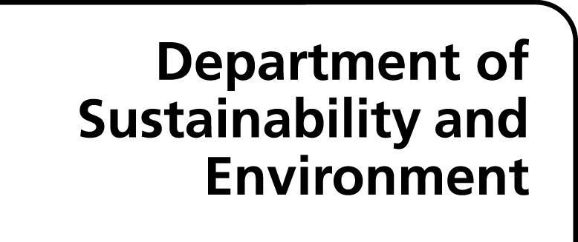
Acceptable easement purposes on new Plans of Subdivision
April 2013
Land Victoria recognises that this may not be an exhaustive list of all acceptable easement purposes. Other easement purposes may be acceptable on plans of subdivision, but these would have to be sanctioned by Land Victoria prior to recording.
Group 1 – Easements that can be accepted without further qualification
- Air Supply (further easement purposes relating to air)
  - Flow of air
  - Passage of air
  - Air exhaust and ventilation
- Carriageway (further easement purposes relating to Carriageway see Group 2 Carriageway)
- Drainage (further easement purposes relating to drainage)
  - Drainage and Floodway
  - Drainage and Sewerage
  - Drainage and Waterway
- Erosion
- Fire (easement purposes relating to fire)
  - Fire access
  - Fire escape
  - Fire egress
- Floodway
- Flooding
- Submergence
- Flow of Light and Air
- Footway (further easement purposes relating to Footway see Group 2 Use of stairway)
- Gas (easement purposes relating to gas)
  - Gas distribution pipeline
  - Gas transmission pipeline
  - Supply of gas
- Light (easement purposes relating to light)
  - Flow of light
  - Passage of light
- Overhanging Eaves/Spouting/Balcony
- Party Wall/Chimney
- Passage of Light and Air
- Pipeline or Ancillary Purposes (Section 136 Water Act 1989)
- Powerline (Section 88 Electricity Industry Act 2000)
- Sewerage
- Soakage by Water
- Walkway (further easement purposes relating to walkway)
  - Walkway in the event of ‘activity’ (e.g. flood) in ‘specific location’ (e.g. Smith Street)
- Waterway (further easement purposes relating to waterway)
  - Waterway Management
- Way (further easement purposes relating to Way see Group 2 Mail collection)
Group 2 – Easements that can be accepted with further qualification
Note: some of the easements listed below were historically accepted at Land Victoria without qualification, but now require further qualification to be recorded.
- Carriageway (e.g. easement of carriageway for – a specific purpose – loading and unloading heavy equipment)
- Channel (e.g. Channel easement for the passage of water)
- Data transmission (define the method of transmission e.g. overhead/underground cable etc.)
- Electricity (easement purposes relating to electricity)
  - Supply of electricity (e.g. through underground cable/overhead powerline)
  - Transmission of electricity (e.g. through underground cable/overhead powerline)
- Ground water monitoring (e.g. right to enter onto servient land from time to time for the purposes of monitoring ground water levels, or similar)
- Irrigation (e.g. flow of water through pipeline or channel – as applicable – for the purpose of irrigation)
- Mail collection (e.g. easement of way for the purpose of collecting mail, or very similar)
- Right of Access (define both the purpose and means of access e.g. access by foot for the purpose of using a storage shed)
- Right of Entry (define both the purpose and means of entry e.g. entry by emergency vehicles in the event of fire)
- Sanitary convenience (e.g. easement for the use – from time to time – of sanitary conveniences located on the servient land)
- Supply of recycled water (e.g. through underground pipes/channels)
- Supply of water (e.g. through underground pipes)
- Support (define what is being supported and by what method)
- Telecommunications (e.g. transmission of telecommunication signals by ‘underground cable’)
- Underground effluent disposal (e.g. flow of effluent through underground effluent disposal system; however, underground effluent disposal installation is not acceptable)
- Use of stairway (e.g. easement of footway over stairs, or very similar)
- Vehicle parking (full and free right and liberty to and for the registered proprietor for the time being of the dominant tenement and his servants, agents, workmen and visitors to use the land marked (XX) for the purpose of parking vehicles between the hours of (XX) to (XX) Monday to Friday and (XX) to (XX) on Saturday)
- Waste disposal (Define the type of waste. If this is an easement to permit the flow of effluent across the servient land, this needs to be explicitly set out, including the manner in which it is to flow – across the land or through a pipeline or channel. In situations where the manner of flow is unknown at the time of registration, a combination of flow types may be acceptable e.g. waste water disposal by either underground soakage system and/or above ground irrigation system.)
- Wetland – detailed qualification required – Land Victoria often receive MCPs (Memorandum of Common Provisions) containing lengthy qualifications describing this type of easement

Land Victoria
Level 11, 570 Bourke Street,
MELBOURNE 3000
www.dse.vic.gov.au/property

Disclaimer
© The State of Victoria, Department of Sustainability and Environment, 2011
Disclaimer: This publication may be of assistance to you but the State of Victoria and its employees do not guarantee that the publication is any kind or is wholly appropriate for your particular purpose and therefore disclaims liability for any error, loss or other consequence which may arise from you relying on any information in this publication.

Copyright
Apart from fair dealing for the purposes of private study, research, criticism or review as permitted under the Copyright Act 1968, no part of this presentation may be reproduced, copied, transmitted in any form or by any means (electronic, mechanical or graphic) without the prior written permission of the State of Victoria. All requests and enquiries should be directed to Land Victoria.

