Vicmap Vector Basemaps

User Guide

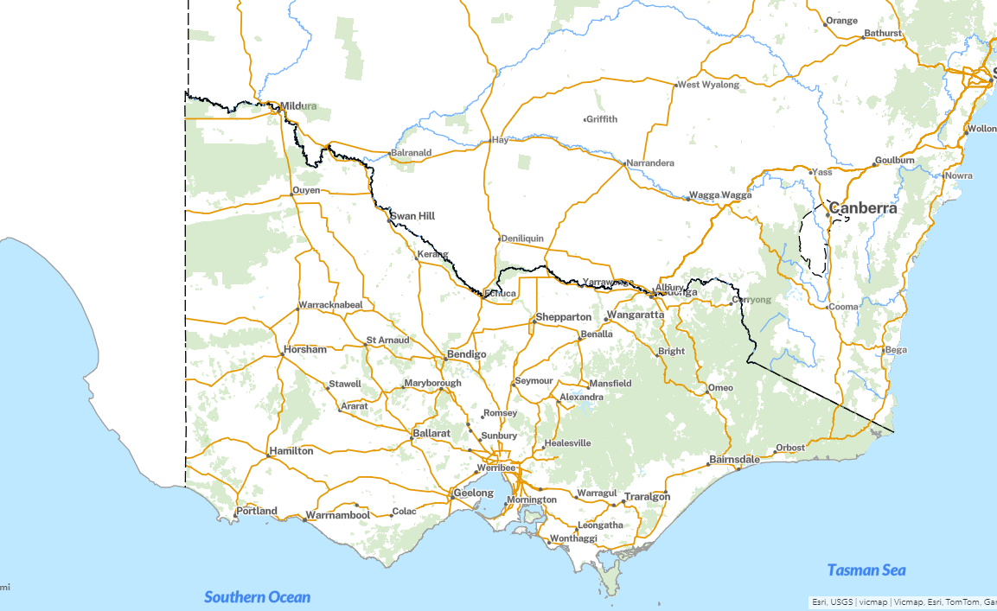



# Document Control

|  |  |  |
| --- | --- | --- |
| Version | Date | Note |
| 1.0 | 2024 | Original release in 2024. |
|  |  |  |
|  |  |  |
|  |  |  |

Contents

Document Control 1

Background 3

Part A: Service Descriptions 4

Vicmap Vector Basemap Colour 5

Vicmap Vector Basemap Hybrid 6

Vicmap Vector Basemap Greyscale 7

Vicmap Vector Basemap Dark Grey 8

Part C: Service Connection Guide 9

Connecting via ArcGIS Pro v2+, 3+ 10

Adding an ESRI Rest Server (ArcGIS Server) Connection 11

Adding Services from an ESRI Rest Server (ArcGIS Server) Connection 13

Part D: Service Maintenance and Support 15

Maintenance and Service Levels 16

Support Requests 16

Communication of Vicmap Basemap changes 16

Background

The Vicmap Vector Basemaps were set up as a collaboration between NSW and Victoria to ensure a seamless, cross border basemap.

The styling used mimicked NSW Spatial Services styling. As there are differences between the geospatial representation of data across the states, there may be some differences between a class code 4 road in Victoria and how that road is represented in NSW.

Likewise, in Victoria, some efforts were made to include cultural, features of interest, and park names, to provide an extra level of detail at closer scales.

You can find more information about the various basemap products on the [hub site](https://enterprise.mapshare.vic.gov.au/portal/apps/sites/#/vicmap-basemaps)

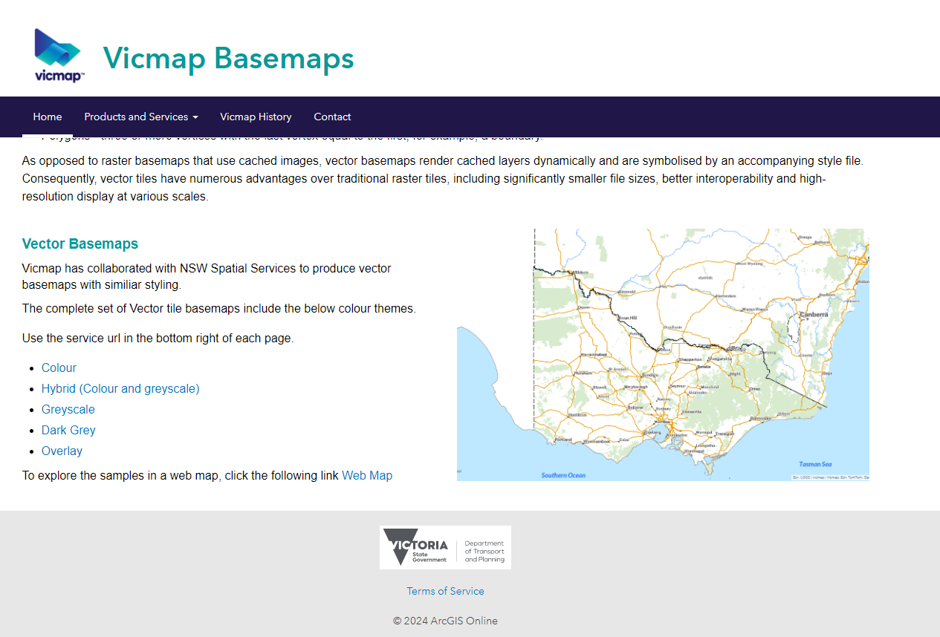

# Part A: Service Descriptions

## Vicmap Vector Basemap Colour

|  |  |
| --- | --- |
| **Description** | The vector tile Vicmap Basemap Colour theme service provides provides a seamless state-wide map of roads, features of interest, localities, hydrology, land cover, property boundaries, cultural data. |
| **Key Design Purpose** | The standard colour map, the most popular map |
| **Available Service Interfaces** | |  |  |  |  |  | | --- | --- | --- | --- | --- | | **ESRI REST** | **WMS** | **WCS** | **WMTS** | **WFS/OGC API** | | ✔ | ✘ | ✘ | ✘ | ✘ | |
| **Service URLs** | |  |  | | --- | --- | | **ESRI REST Service** | <https://vicmap.land.vic.gov.au/hosting/rest/services/Hosted/Vicmap_Vector_Tile_Basemap_Colour_WM_Hosted/VectorTileServer> | |
| **Coordinate Reference System** | |  |  | | --- | --- | | **EPSG Code** | 3857 | | **Name** | Web Mercator | |
| **Colour** |  |
| **Dark Grey** |  |

.

## Vicmap Vector Basemap Hybrid

|  |  |
| --- | --- |
| **Description** | The vector tile Vicmap Basemap Hybrid theme service provides a seamless state-wide map delivered in a combination of greyscale and colour. |
| **Key Design Purpose** | A cross between colour and greyscale |
| **Available Service Interfaces** | |  |  |  |  |  | | --- | --- | --- | --- | --- | | **ESRI REST** | **WMS** | **WCS** | **WMTS** | **WFS/OGC API** | | ✔ | ✘ | ✘ | ✘ | ✘ | |
| **Service URLs** | |  |  | | --- | --- | | **ESRI REST Service** | <https://vicmap.land.vic.gov.au/hosting/rest/services/Hosted/Vicmap_Vector_Tile_Basemap_Hybrid_WM_Hosted/VectorTileServer> | |
| **Coordinate Reference System** | |  |  | | --- | --- | | **EPSG Code** | 3857 | | **Name** | Web Mercator | |
| **Hybrid** |  |

## Vicmap Vector Basemap Greyscale

|  |  |
| --- | --- |
| **Description** | The vector tile Vicmap Basemap Colour theme service provides provides a seamless state-wide map of roads, features of interest, localities, hydrology, land cover, property boundaries, cultural data. |
| **Key Design Purpose** | Use as a colourless background to make coloured layers pop out |
| **Available Service Interfaces** | |  |  |  |  |  | | --- | --- | --- | --- | --- | | **ESRI REST** | **WMS** | **WCS** | **WMTS** | **WFS/OGC API** | | ✔ | ✘ | ✘ | ✘ | ✘ | |
| **Service URLs** | |  |  | | --- | --- | | **ESRI REST Service** | <https://vicmap.land.vic.gov.au/hosting/rest/services/Hosted/Vicmap_Vector_Tile_Basemap_Greyscale_WM_Hosted/VectorTileServer> | |
| **Coordinate Reference System** | |  |  | | --- | --- | | **EPSG Code** | 3857 | | **Name** | Web Mercator | |
| **Colour** |  |

## Vicmap Vector Basemap Dark Grey

|  |  |
| --- | --- |
| **Description** | The vector tile Vicmap Basemap Colour theme service provides provides a seamless state-wide map of roads, features of interest, localities, hydrology, land cover, property boundaries, cultural data. |
| **Key Design Purpose** | To provide a night mode type basemap, good for showing project areas |
| **Available Service Interfaces** | |  |  |  |  |  | | --- | --- | --- | --- | --- | | **ESRI REST** | **WMS** | **WCS** | **WMTS** | **WFS/OGC API** | | ✔ | ✘ | ✘ | ✘ | ✘ | |
| **Service URLs** | |  |  | | --- | --- | | **ESRI REST Service** | <https://vicmap.land.vic.gov.au/hosting/rest/services/Hosted/Vicmap_Vector_Tile_Basemap_DarkGrey_WM_Hosted/VectorTileServer> | |
| **Coordinate Reference System** | |  |  | | --- | --- | | **EPSG Code** | 3857 | | **Name** | Web Mercator | |
| **Colour** |  |

# Part C: Service Connection Guide

## Connecting via ArcGIS Pro v2+, 3+

### Note that the vector tile basemaps will not work in ArcMap

### Adding an ESRI Rest Server (ArcGIS Server) Connection

a. From the ArcGIS Pro start screen open any project or “Start without a template” and then open a New Map

b. Click on add data

c. Add data from Path

d. Paste url from above arcgis server url: e.g

|  |  |
| --- | --- |
| **Server Name** | **Server URL** |
| Vicmap Vector Basemap Colour | 1. <https://vicmap.land.vic.gov.au/hosting/rest/services/Hosted/Vicmap_Vector_Tile_Basemap_Colour_WM_Hosted/VectorTileServer> |

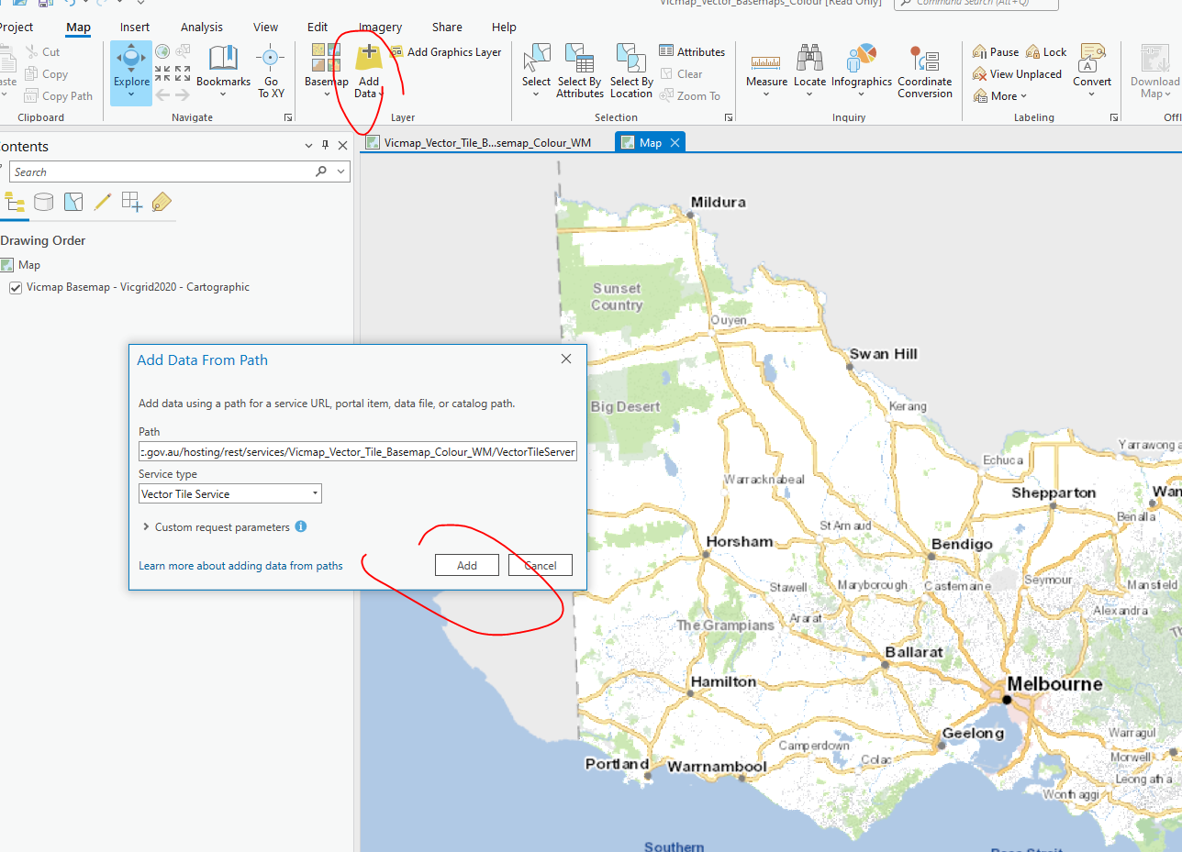

g. Click Add

h. The vector tile map will be visible

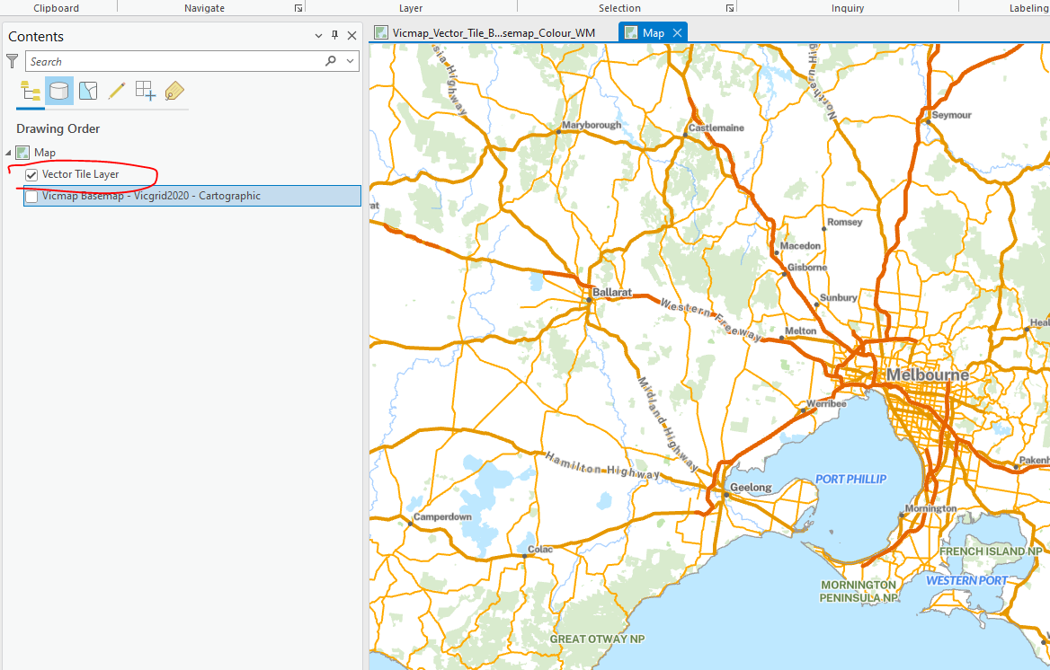

### 

## Connecting via QGIS V3.36

### Adding an ESRI Rest Server (ArcGIS Server) Connection

1. Under browser,select vector tiles and “add new arcgis vector tile service connection”
2. Paste Service url in service url area

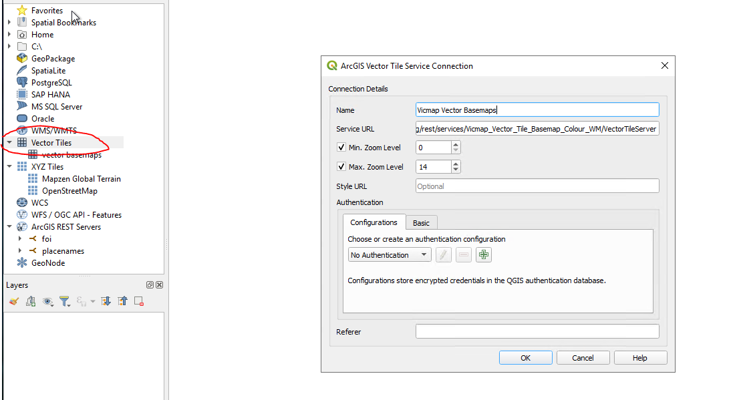

Drag vector tile service from browser window into layers window

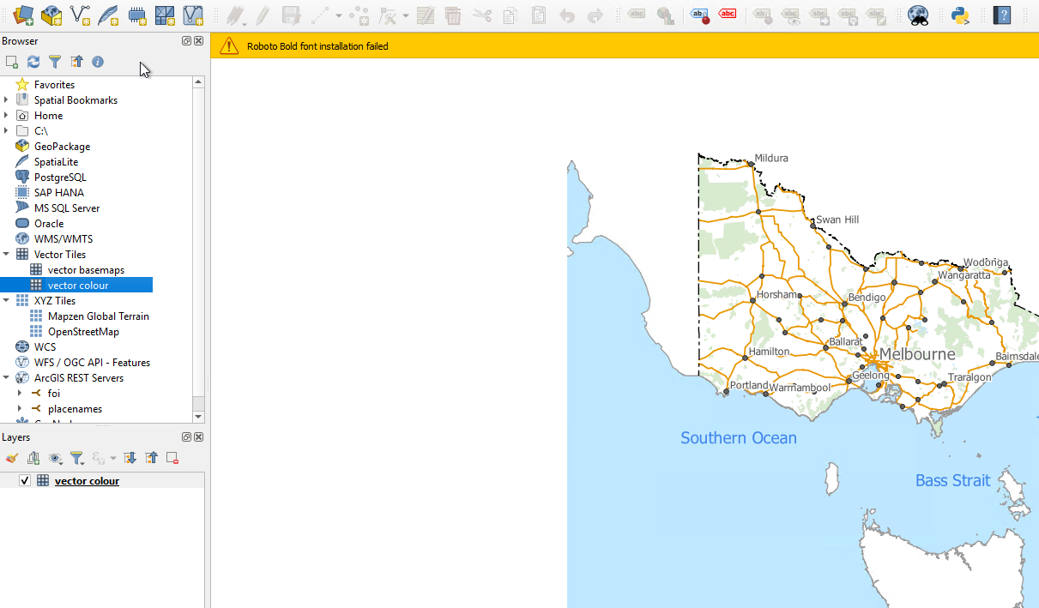

1. Click ‘Close’ at the bottom of the Data Source Manager window.

### Adding Services from an ESRI Rest Server (ArcGIS Server) Connection

Following on from the steps for Adding an ESRI Rest Server (ArcGIS Server) Connection.

In the browser pane your added ArcGIS Server connection will appear underneath ‘ArcGIS REST Services’. It will appear as whatever you named it at step d. You can click to expand the server and the service folders hosted on the server. Services will appear with a checkerboard icon as shown below.

1. To add a service to your map, right click on it and select ‘Add Layer to Project’

## 

# Part D: Service Maintenance and Support

## Maintenance and Service Levels

1. The basemaps are updated automatically on Sunday night, after the updates of the data
2. Vicmap Vector Basemap services are designed to be operational 24/7, however this cannot be guaranteed.
3. Support for the services will be available during standard business workday times: 9am-5pm Monday to Friday, excluding public holidays.
4. Vicmap will endeavour to respond to support requests within 2 business workdays.

## Support Requests

All Vicmap basemap enquiries should be directed to [vicmap@transport.vic.gov.au](mailto:vicmap@transport.vic.gov.au)

## Communication of Vicmap Basemap changes

Notices of Vicmap Basemap updates will be made through Vicmap Change Notices.