Guide to Certificates of Title and Administrative Notices

August 2024



Contents

Certificates of Title 2

Use of Certificates of Title 2

The electronic Certificate of Title (eCT) 2

Administrative Notices 3

Types of Administrative Notices 3

Electronic Administrative Notices 4

Paper Administrative Notice 5

Register Search Statement - samples 6

Business rules for determining eCT Control after a transaction 7

Frequently asked questions 7

Example A 10

Example B 11

Example C 12

Example D 13

Example E 14

This guide sets out information about the use and operation of Certificates of Title (CT) and Administrative Notices in an Electronic Lodgment Network (ELN) and in the Victorian Online Titles System (VOTS) from 3 August 2024.

Certificates of Title

The Register of land comprises individual records called folios. For each folio, there is a CT that is usually issued by the Registrar of Titles (Registrar) after the registration of an instrument affecting the folio, such as a transfer or mortgage. Historically, a paper CT (pCT) was issued as a conclusive, physical certificate of the information on a folio at the date the CT was issued. Since the introduction of ELNs, a CT may be electronic, which is essentially a control mechanism to ensure the effective processing of electronic instruments. If issued prior to 3 August 2024, a CT may have been paper or electronic, but all CTs issued after this date will be electronic.

Use of Certificates of Title

Under the Transfer of Land Act 1958 (TLA), the CT must be ‘nominated’ to an electronic lodgment case or produced with the paper instrument, to enable the lodgment and registration or recording of most instruments. The existence and use of the CT is critical to transacting land in Victoria.

The electronic Certificate of Title (eCT)

Identifying an eCT

Where a folio of the Register has an eCT, this is identified by a notification on a Register Search Statement (RSS) for the folio, under the ADMINISTRATIVE NOTICES heading, which provides the name of the eCT Control. Details of any current Administrative Notices will also appear under this heading.

For further information and examples, please refer to Attachments A, B, C, D and E – the Register Search Statements samples – later in this document.

eCT Control

The eCT Control is the party that has control of the eCT for the folio, as shown on the RSS.

Subscribers to an ELN may hold eCT Control, or it may be held by the Registrar. Some government bodies and statutory authorities can also hold eCT Control.

Only subscribers to an ELN can take actions in respect of eCT Control, such as relinquishing or receiving eCT Control. eCT Control can be held by the Registrar, but the Registrar’s role is passive. A subscriber to an ELN may request eCT Control from the Registrar or may request to pass eCT Control to the Registrar, but these actions are initiated and managed solely by the subscriber and require no intervention or action by the Registrar.

eCT Control may be held by a government body or a statutory authority. If the body or authority is an ELN subscriber, it may take actions in respect of eCT Control. If the body or authority is not an ELN subscriber, the body or authority must appoint an ELN subscriber to take any action required on their behalf.

CTs and transactions

If a folio has an existing pCT, it must be produced to support lodgment of a paper transaction. For an electronic transaction, an existing pCT must be converted to eCT to support lodgment.

From the registration of any transaction requiring a CT, whether lodged as paper or electronically, an eCT will be issued.

From the registration of a paper transaction, eCT Control will be held by the Registrar. From the registration of an electronic transaction, eCT Control will be determined by applying the business rules outlined in the Business rules for determining eCT Control from the processing of a transaction section of this guide.

Converting pCT to eCT

All existing pCTs remain legally valid. Subscribers can retain pCTs in their current paper format or may choose to convert some or all to eCT. A subscriber wishing to convert a small number of pCTs (up to 50) that are in their possession or control, can use the LUV paper Administrative Notice – *Convert a paper Certificate of Title to an electronic Certificate of Title.* Further details are under the heading *Completing the paper Administrative Notice* of this document.

Upon creation of the eCT, the subscriber making the request will become the eCT Control.

If a subscriber wants to convert more than 50 pCTs to eCT, this can be done by using a bulk conversion process. For further information please send a request using the [online enquiry form](https://servictoria.com.au/contact/submit-an-enquiry).

Converting pCT to eCT to support an electronic transaction

If a folio has a pCT, it must be converted to eCT to support lodgment of an electronic transaction. In this circumstance, a subscriber can use the electronic Administrative Notice available in an ELN – *Convert pCT and Nominate to Lodgement Case*. Further details are contained in the Administrative Notices section below.

Administrative Notices

Administrative Notices are used to request that the Registrar deal with a CT in a particular way. The Administrative Notice provides a set of instructions about the use and control of the eCT.

Administrative Notices are allocated a number and are recorded in VOTS, but they do not form part of the Register of land. They are dealt with in the order they are received.

An Administrative Notice can appear in two sections of an RSS – under the heading ADMINISTRATIVE NOTICES or under the ACTIVITY IN THE LAST 125 DAYS heading.

For further information and examples, please refer to Attachments A, B, C and D – the Register Search Statement samples – later in this document.

Types of Administrative Notices

Administrative Notices request the Registrar to act on the instructions of the person with control of the CT.

There are eight Administrative Notices: seven are available in an ELN and must be lodged electronically using an ELN and one is a paper-based land registry form.

Electronic Administrative Notices

|  |  |
| --- | --- |
| **Administrative Notice** | **Description and requirements** |
| ***Convert pCT and Nominate eCT to Lodgment Case*** | Enables a subscriber to request the conversion of a pCT to an eCT, and its nomination to support lodgment of an electronic transaction in a Lodgment Case. These two processes cannot be decoupled.  In an ELN, a Lodgment Case is an electronic file used to submit electronic transactions to LUV for lodgment.  This Administrative Notice requires the ELN subscriber to certify as to possession of and either destruction or invalidation of the pCT referenced in the Administrative Notice.  Acceptable methods of destruction or invalidation  The ELN subscriber can elect either to securely destroy a pCT or to render it invalid.  An appropriate and recommended secure destruction method would be to shred the pCT and securely dispose of the shredded waste.  Another option to render a pCT invalid is to stamp the pCT with the words ‘INVALID – CANNOT BE USED FOR ANY LEGAL PURPOSE’. This should be done in all cases where the pCT is not destroyed, and particularly when the subscriber’s client requires the return of the invalidated pCT for sentimental or other reasons.  Possession of the pCT to be destroyed or invalidated  The subscriber requesting the conversion and nomination of a pCT must have possession of the pCT at the time the Administrative Notice is signed.  **This Administrative Notice cannot be used where a pCT has been lost, stolen or is missing. The correct procedure in these instances is to lodge an Application under Section 31 of the TLA for a new CT in place of the one lost. This application is available in an ELN. The new CT issued will be an eCT.** |
| Nominate eCT to Lodgment Case | Where the CT is an eCT, the eCT Control can use this Administrative Notice to nominate the eCT to support a Lodgment Case. |
| Nominate eCT to Paper Instrument | If an eCT is required to support lodgment of a paper instrument, the eCT Control can use this Administrative Notice to nominate the eCT to enable the proposed paper instrument to be lodged. |
| Withdraw eCT Nomination | Withdraw an eCT nomination from either a Lodgement Case or a paper instrument. This request can only be made by the subscriber who lodged the nomination Administrative Notice. |
| Transfer control of an eCT | Enables the transfer of eCT control from one subscriber to another subscriber. Both relinquishing and receiving subscribers must sign the Administrative Notice. |
| Request eCT Control from Registrar of Titles | Where eCT Control is held by the Registrar of Titles, this Administrative Notice is used by a subscriber to request eCT Control. This Administrative Notice is signed only by the requesting subscriber. |
| Request to transfer eCT Control to Registrar of Titles | If a subscriber no longer wishes to hold eCT Control, it can be passed to the Registrar using this Administrative Notice. This Administrative Notice is signed only by the requesting subscriber. |

Completing electronic Administrative Notices

Electronic Administrative Notices can only be accessed by ELN subscribers.

ELN provides functionality to create the various Administrative Notices, based on a series of selections and data values provided by the subscriber.

The ELN submits these documents to LUV for processing.

For further information on completing electronic Administrative Notices in an ELN, please contact the ELN provider.

Paper Administrative Notice

Convert a paper Certificate of Title to an electronic Certificate of Title

If an electronic transaction is not anticipated and a subscriber wants to convert a pCT to eCT, a paper Convert a paper Certificate of Title to an electronic Certificate of Title should be used.

This Administrative Notice requires the subscriber to certify that in relation to the pCT the subject of the application that they have retrieved the pCT and either destroyed or made it invalid.

Acceptable methods of destruction or invalidation are discussed under the heading *Convert pCT and Nominate eCT to Lodgement Case* earlier in this guide.

The subscriber requesting the conversion of a pCT to eCT must have possession of that pCT at the time the Administrative Notice is signed.

Once processed, the subscriber will be the eCT Control of the CT(s) referenced in the Administrative Notice.

This Administrative Notice can be used to convert up to 50 pCTs. If a larger number of pCTs require conversion, can be done by using a bulk conversion process. For further information please send a request using the [online enquiry form](https://servictoria.com.au/contact/submit-an-enquiry).

Sample Paper Administrative Notice

The completed form should be submitted using the [online enquiry form](https://servictoria.com.au/contact/submit-an-enquiry).

Register Search Statement - samples

Whether a CT is a pCT or eCT can be determined by obtaining a current Register Search Statement (RSS) of the relevant folio and using the following steps:

1. locate the Additional information section on the RSS, generally towards the bottom of the document
2. does this section contain the heading ADMINISTRATIVE NOTICES:
   * + if no, then the CT is paper
     + if yes, the CT is an eCT and the details of the eCT Control will be shown

The details of any current Administrative Notice will appear under the heading ADMINISTRATIVE NOTICES. If an Administrative Notice was lodged within 125 days preceding the date of the RSS, the details of the notice may also appear under the heading ACTIVITY IN THE LAST 125 DAYS.

For further clarity, refer to the samples A-E of RSS at the end of this document.

Business rules for determining eCT Control after a transaction

Where a folio is **not** cancelled (i.e. a transaction that only requires an endorsement on the folio) lodgment instructions will determine eCT control.

Where a folio is to be cancelled as a result of a transaction, and new folios are to be issued, the following business rules determine eCT control of the new folios at registration of the transaction.

|  |  |  |  |
| --- | --- | --- | --- |
| **Folio type** | **Standard output where parties are represented by an ELN subscriber** | **Plan of subdivision where the parent folios have different controlling parties** | **Non-represented party lodgments** |
| Folio(s) subject to a mortgage (including as to part) | eCT control will issue to the controlling party for the mortgagee (either the nominating party or the lodging party who holds eCT control) | eCT control will issue to the controlling party of the mortgage that is first in priority. | eCT control will issue to the controlling party for the mortgagee |
| Folio(s) **not** subject to a mortgage | eCT control will issue to the lodging party of the instrument | eCT control will issue to the lodging party | eCT control will issue to the Registrar |
| Folio(s) for common property | A CT is not issued for common property folios. | | |
| Folios for roads and reserves | eCT control will issue to the vesting authority if they are an ELN subscriber.  eCT control will issue to the Registrar if the vesting authority is not an ELN subscriber. | | |

Frequently asked questions

|  |  |
| --- | --- |
| Question | Answer |
| **How does ABC Solicitors, an ELN subscriber, nominate a pCT to a Lodgement Case?** | ABC Solicitors can nominate a pCT to a Lodgement Case using the Administrative Notice in an ELN - *Convert pCT and Nominate eCT to Lodgement Case.* |
| **How does Conveyancing Pty Ltd, an ELN subscriber, nominate to a Lodgement Case an eCT where it is eCT Control?** | Conveyancing Pty Ltd can nominate the eCT to a Lodgement Case using the Administrative Notice in an ELN - *Nominate eCT to Lodgement Case*. |
| **Solicitors Pty Ltd, an ELN subscriber, has nominated an eCT to a Lodgement Case but now has instructions that the transaction is not proceeding. How can the nomination be removed?** | Solicitors Pty Ltd can withdraw the nomination of an eCT from the Lodgement Case using the Administrative Notice in an ELN - *Withdraw eCT Nomination*. |
| **How does Conveyancing Pty Ltd, a subscriber to the ELN, convert one or more of their pCTs to eCT, independent of nominating the eCT to a transaction?** | Conveyancing Pty Ltd can convert one or more of their pCTs into eCT(s) using the LUV paper Administrative Notice *-* *Convert a paper Certificate of Title to an electronic Certificate of Title*. A maximum of 50 pCTs can be included in a request. If Conveyancing Pty Ltd wishes to convert more than 50 of their pCTs (a bulk conversion), this can be arranged by contacting the Registration Operations Manager at LUV – for contact details see page 3. |
| **How does Conveyancing Pty Ltd, a subscriber to the ELN, transfer control of an eCT to Solicitors Pty Ltd, another ELN subscriber?** | Conveyancing Pty Ltd can transfer control of an eCT of which it is eCT Control to another ELN subscriber using the Administrative Notice in the ELN - *Transfer Control of an eCT*. The Administrative Notice must be signed by both Conveyancing Pty Ltd and Solicitors Pty Ltd. |
| **How does Michael Jones, who is not an ELN subscriber, deal with his land when the CT is held as an eCT by ABC Bank Ltd, a mortgagee that has discharged its mortgage but has retained eCT Control?** | There are two options available to Michael Jones, depending on the circumstances of the proposed transaction.  Michael can request ABC Bank Ltd to nominate the eCT to the proposed transaction, even if ABC Bank Ltd will not be involved in the proposed transaction. ABC Bank Ltd would do this using the appropriate Administrative Notice in the ELN – either *Nominate eCT to Lodgement Case* or *Nominate eCT to Paper Instrument*.  Alternatively, Michael can request ABC Bank Ltd to transfer control of the eCT to his conveyancer or lawyer, who must also be an ELN subscriber. ABC Bank Ltd would achieve this using the Administrative Notice in the ELN – *Transfer control of an eCT*. |
| **How does Michael Jones, who is not a subscriber to the ELN, mortgage his land to First Bank Ltd, when he holds the CT as a pCT?** | Michael would give the new mortgagee, First Bank Ltd, an executed paper mortgage and the pCT.  First Bank Ltd would create a Lodgement Case in an ELN for the new mortgage.  First Bank Ltd would lodge an Administrative Notice in the ELN - *Convert pCT and Nominate eCT to Lodgement Case*.  Following processing of the Administrative Notice, First Bank Ltd will be the eCT Control.  First Bank Ltd would complete lodgement instructions selecting the ‘stay’ option, i.e. ‘return eCT Control to the nominating Subscriber’.  First Bank Ltd would then lodge the Lodgement Case containing the new mortgage and the lodging instructions.  Following registration of the mortgage, an RSS would show that the mortgage had been registered and that First Bank Ltd is the eCT Control. |
| **How does a person searching a folio know which instrument an eCT has been nominated to?** | The RSS may show, under the heading ACTIVITY IN THE LAST 125 DAYS, that either the Administrative Notice *Convert pCT and Nominate eCT to Lodgement Case* or the Administrative Notice *Nominate eCT to Lodgement Case* was completed. This alerts anyone searching the folio that an electronic transaction is anticipated.  Alternatively, the RSS may show under ACTIVITY IN THE LAST 125 DAYS that the Administrative Notice *Nominate eCT to paper instrument* was completed. This alerts anyone searching the folio that a paper transaction is anticipated and provides a basic description of the expected transaction.  At that point in time, LUV has no information about the instrument(s) in the Lodgement Case or any more detail of an anticipated paper transaction. A person seeking further information about the contents of the Lodgement Case or more detail on an anticipated paper transaction should contact the eCT Control. Details of eCT Control appear in the Additional information section of the RSS, under ADMINISTRATIVE NOTICES. |

Example A

The CT is a pCT, there has been activity in the last 125 days and there is no current Administrative Notice.

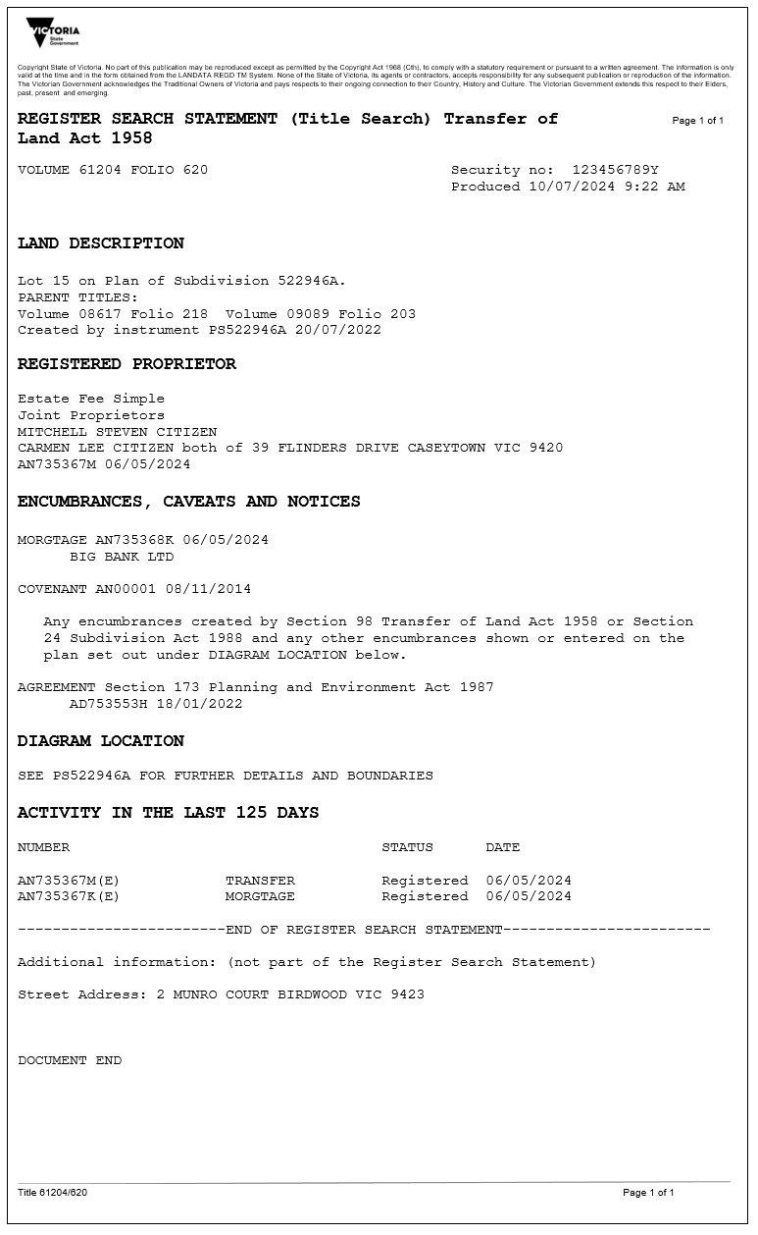

Example B

The CT is in an eCT, the eCT Control is ABC Bank Ltd, there is a current Administrative Notice nominating the eCT to a pending paper transaction (a Discharge of Mortgage) and the Administrative Notice was lodged within the 125 days preceding the date of the RSS.

Example C

The CT is in an eCT, the eCT Control is ABC Bank Ltd, there is a current Administrative Notice nominating the eCT to a pending electronic transaction, and the Administrative Notice was lodged within the 125 days preceding the date of the RSS.

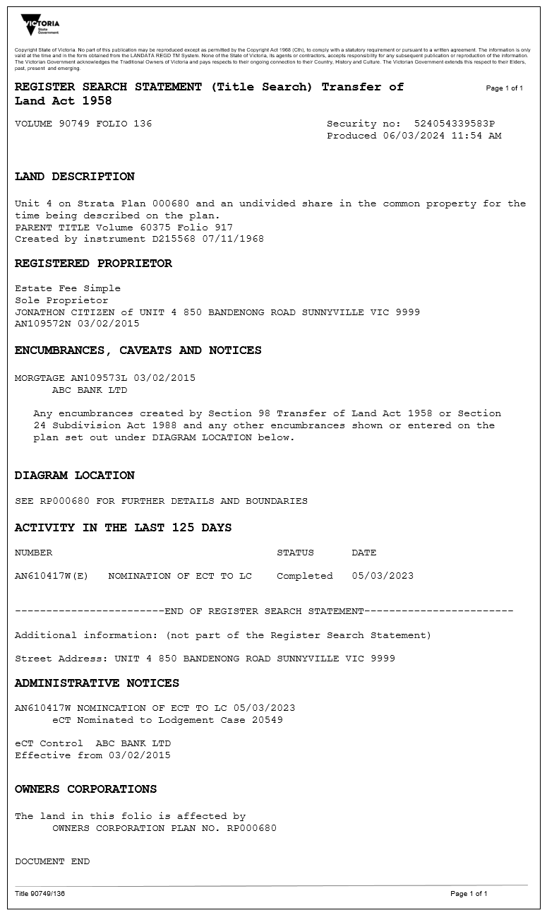

Example D

The CT is an eCT, the eCT Control is Williamvale Shire Council, there has been no activity in the last 125 days and there is no current Administrative Notice.

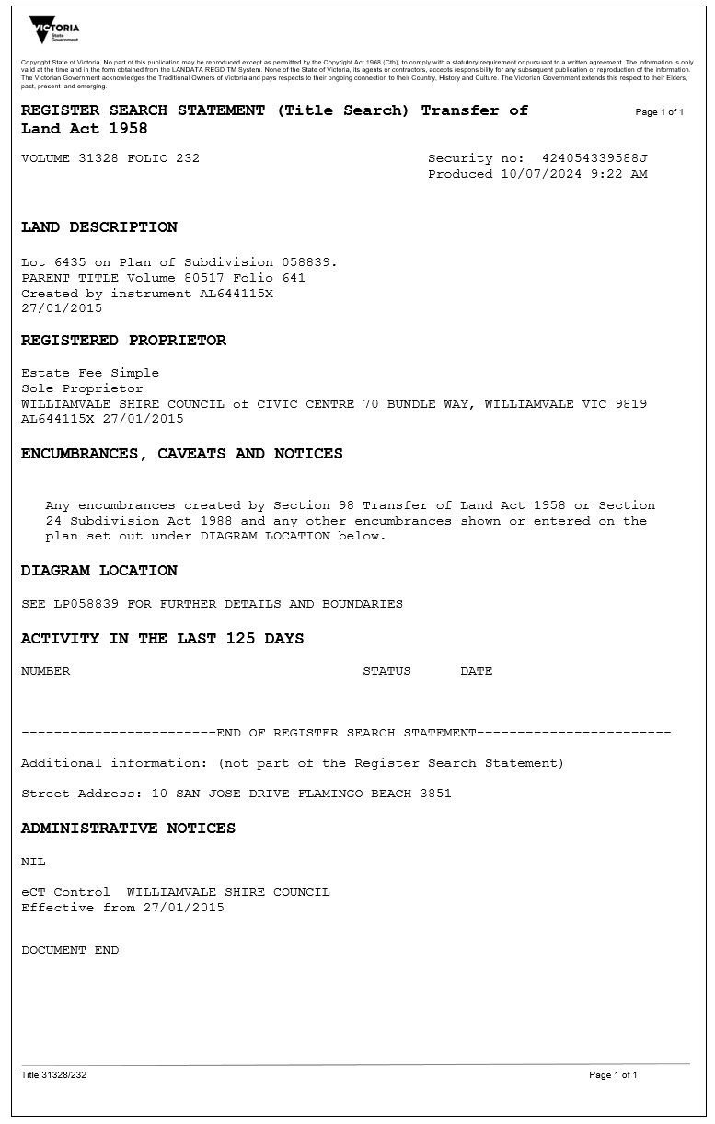

Example E

The CT is in an electronic format, the control of the eCT is with the Registrar, there has been no activity in the last 125 days and there are no current Administrative Notices.

