Land Registry Services   
Business Activity Report

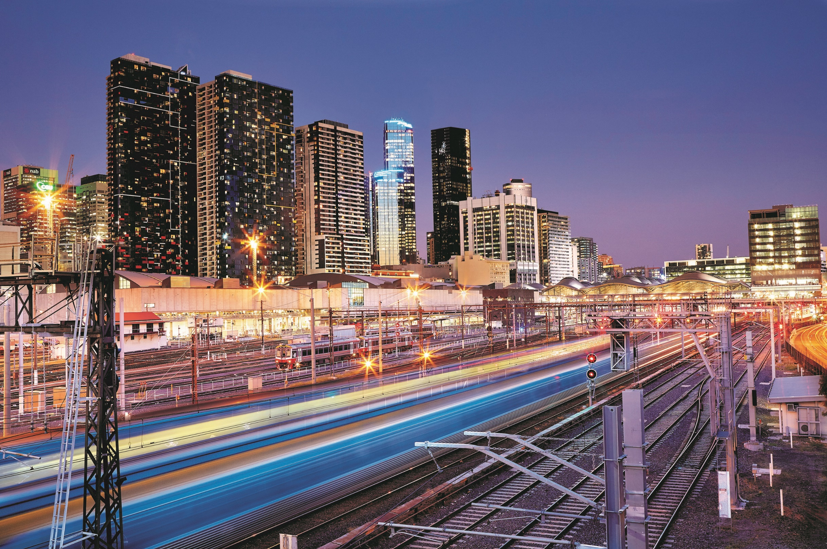

2023-2024 Financial Year



# Table of Contents

Table of Contents 1

Land Registry Services 3

Business activity report 2023-2024 financial year 3

1 Lodgments 3

1.1 Number of dealings lodged 3

1.2 Yearly lodgments (1945-2024) 3

1.3 Monthly lodgments 4

1.4 Average daily lodgments (with trend line) 4

1.5 Financial year lodgments from 2019-2020 to 2023-2024 (by month) 6

2 Search 7

2.1 Title searches 7

2.2 Financial year title searches (by month) 7

2.3 Planning certificates 8

2.4 Instrument searches 8

2.5 Property certificates 9

2.6 Land Index searches 9

3 Lodgment and Support Services 1 (LSS1) 10

3.1 Landata statistics with trend lines 10

4 Water Register 11

4.1 Water share transactions 12

5 Lodgment by specific dealing types 13

5.1 Discharges of mortgage 13

5.2 Transfers of land 13

5.3 Mortgages 14

5.4 Differences in lodging levels and percentages of discharges, transfers, and mortgages 14

5.5 Plans of subdivisions 16

5.6 All Plans lodged under the Subdivision Act 1988 16

5.7 Number of new parcels created from plans of subdivision 17

5.8 General law conversion 17

5.9 Crown Land Dealings 17

5.10 Top 40 dealing types, by number lodged 18

6 Other measures of Land Registry Services activity 19

6.1 Number of dealings registered 19

6.2 Percentage of dealings registered within 5 days 19

6.3 Number of plans of subdivision registered 19

6.4 Number of dealings refused 19

6.5 Number of dealings waiting to be processed 19

7 Electronic transactions processing 19

7.1 Electronic Conveyancing 19

7.2 Percentage of transactions lodged electronically 20

# Land Registry Services

## Business activity report 2023-2024 financial year

This report provides statistics for land registration and property information services conducted at Land Use Victoria. Figures for the 2023-2024 financial year and previous years are provided.

# 1 Lodgments

## 1.1 Number of dealings lodged

The number of dealings lodged for the financial year was 923,235. This is a 2.98 per cent decrease from the 2022-23 financial year but is the third highest lodgment level on record for the Registry. Past financial years’ lodgments are listed below:

| Year | Total | Year | Total |
| --- | --- | --- | --- |
| **2004-2005** | 780,329 | **2014-2015** | 792,335 |
| **2005-2006** | 748,647 | **2015-2016** | 857,497 |
| **2006-2007** | 727,464 | **2016-2017** | 876,482 |
| **2007-2008** | 777,542 | **2017-2018** | 917,385 |
| **2008-2009** | 675,640 | **2018-2019** | 885,058 |
| **2009-2010** | 743,389 | **2019-2020** | 853,227 |
| **2010-2011** | 720,649 | **2020-2021** | 896,843 |
| **2011-2012** | 677,708 | **2021-2022** | 1,022,585 |
| **2012-2013** | 669,214 | **2022-2023** | 951,576 |
| **2013-2014** | 747,598 | **2023-2024** | 923,235 |
| **Table 1: Number of Dealings Lodged  by Financial Year** | | | |

## 1.2 Yearly lodgments (1945-2024)

This graph represents the yearly lodgments for each year since 1945. Since 1945, there has been average growth of 2.96 per cent increase per year.

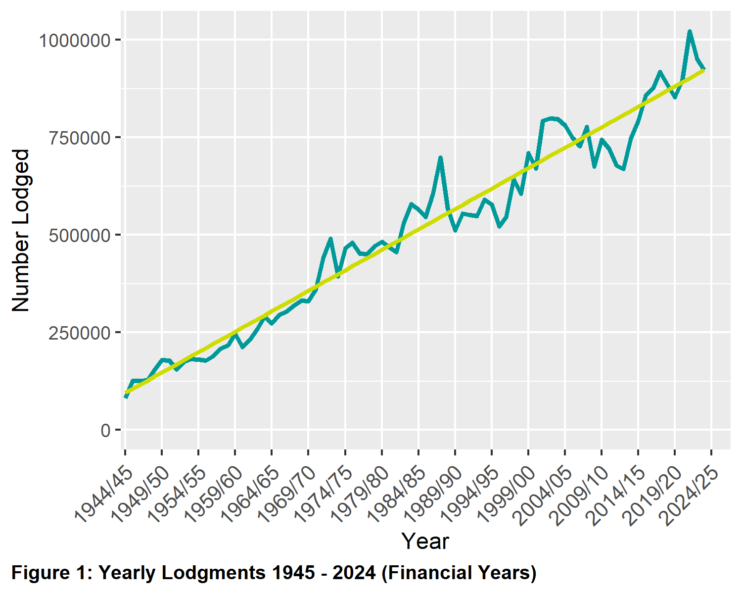

## 1.3 Monthly lodgments

This graph shows the number of lodgments received for each month of the financial year. In the 2023-2024 financial year, the average number of lodgments was 76,936 per month.

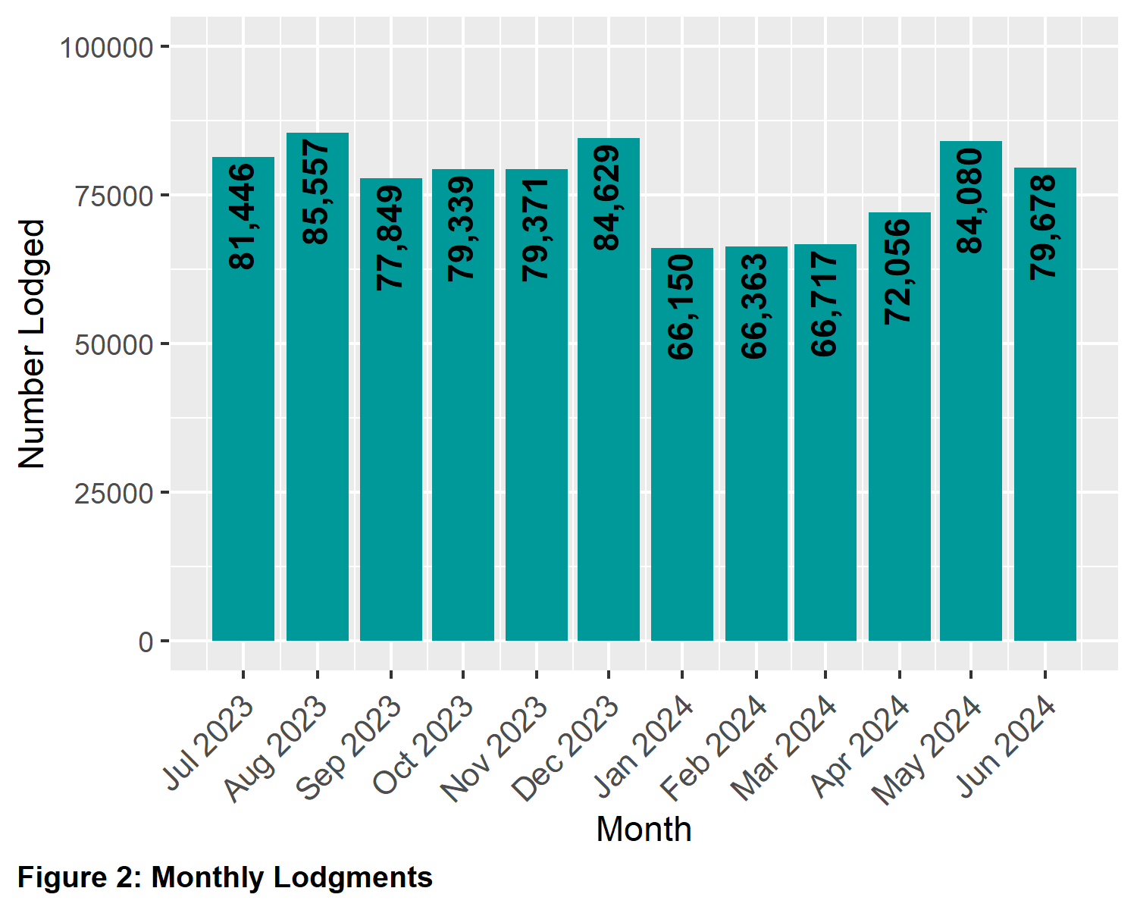

## 1.4 Average daily lodgments (with trend line)

This graph shows the daily average lodgments for each week of the 2023-2024 financial year. The average daily lodgment throughout the financial year was 3,693 per day. The average daily lodgment is monitored on a daily basis (along with moving averages).

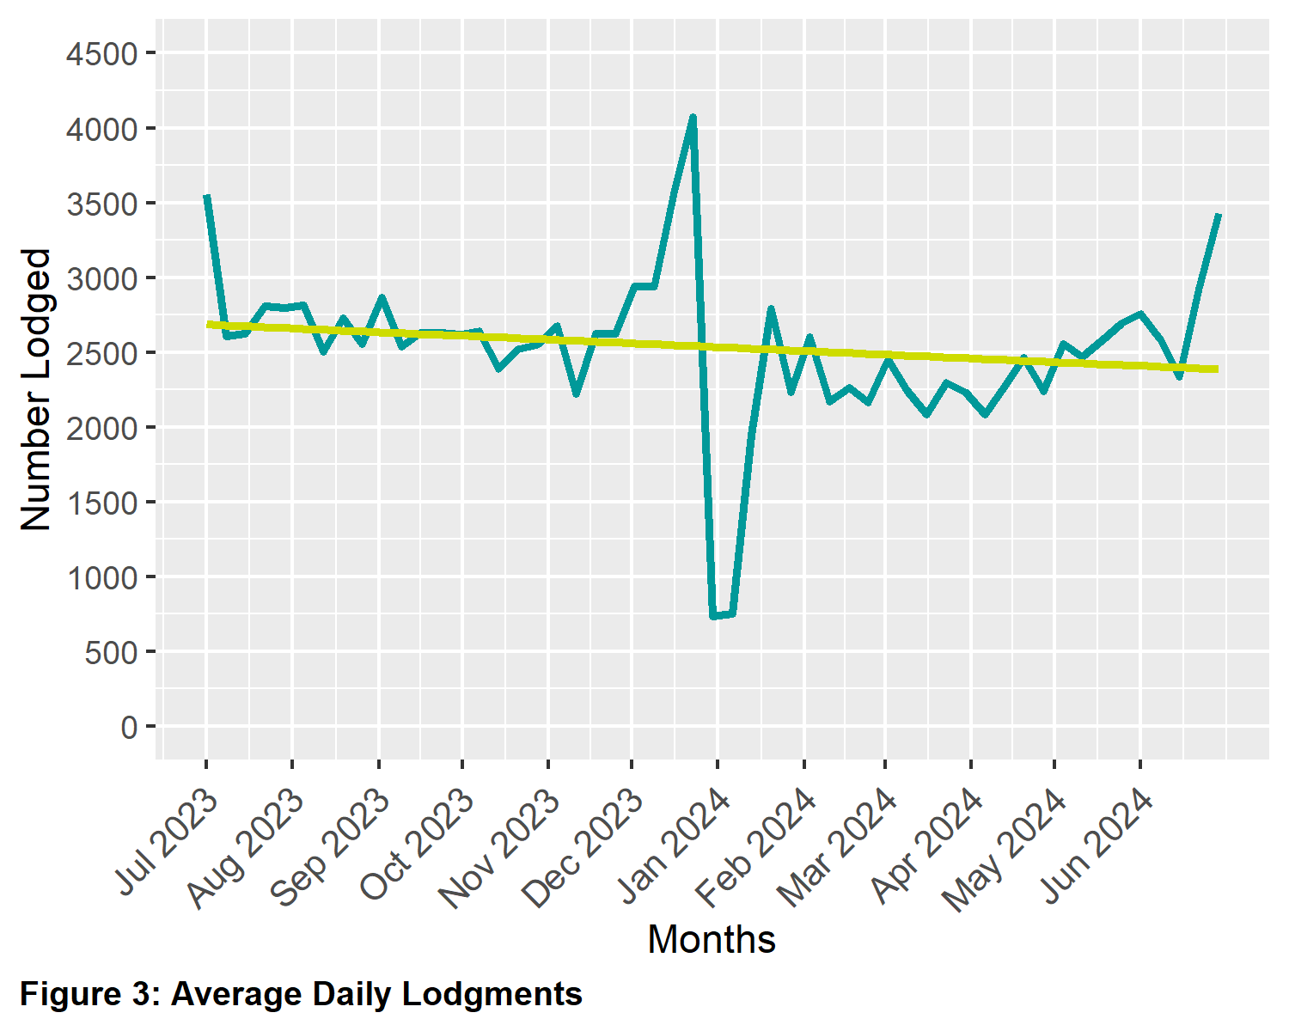

## 1.5 Financial year lodgments from 2019-2020 to 2023-2024 (by month)

This graph compares monthly lodgments since the 2019-2020 financial year.

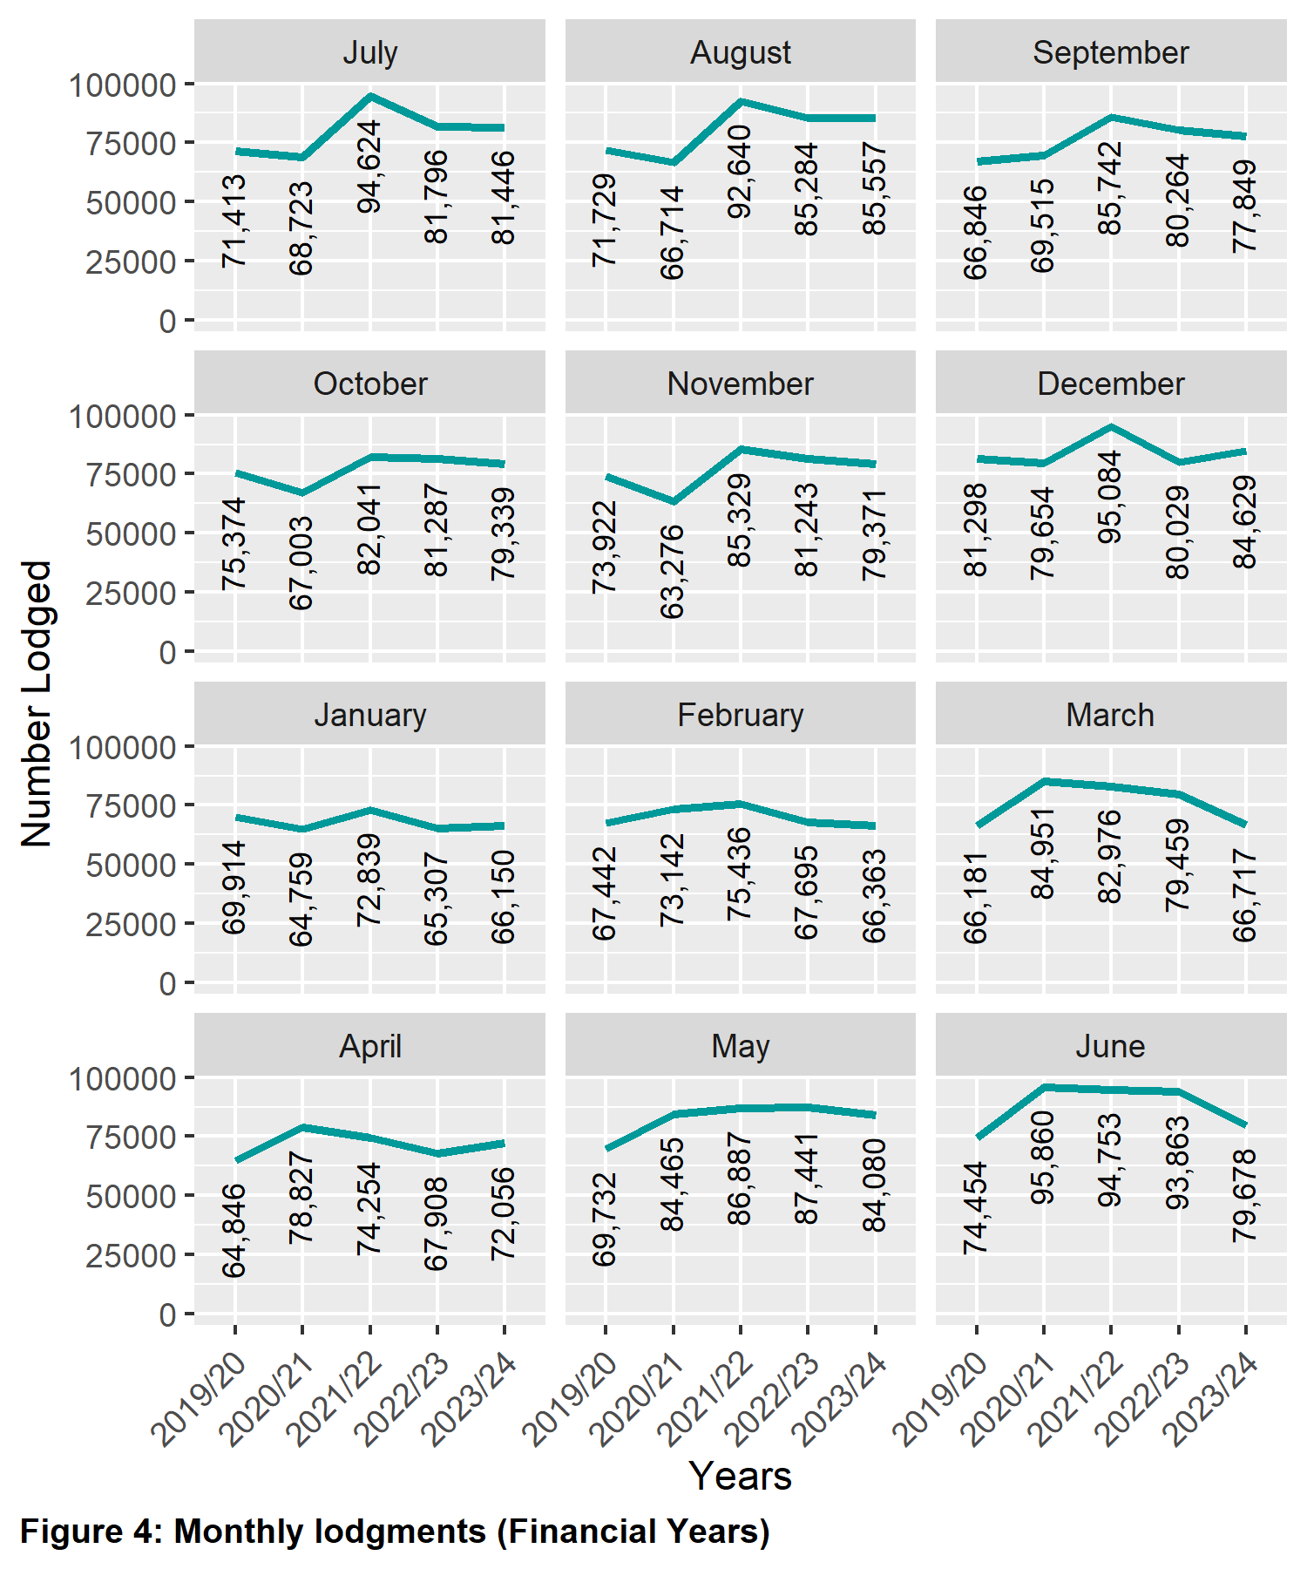

# 2 Search

Search categories are listed below with historical trend information.

## 2.1 Title searches

The number of title searches supplied in the financial year was 2,727,641. This is a 0.37 per cent increase from the 2022-23 financial year.

| Year | Quantity | Year | Quantity |
| --- | --- | --- | --- |
| **2004-2005** | 1,731,553 | **2014-2015** | 2,242,562 |
| **2005-2006** | 1,906,169 | **2015-2016** | 2,232,051 |
| **2006-2007** | 2,050,786 | **2016-2017** | 2,463,249 |
| **2007-2008** | 2,169,427 | **2017-2018** | 2,866,297 |
| **2008-2009** | 2,023,852 | **2018-2019** | 2,483,433 |
| **2009-2010** | 2,200,297 | **2019-2020** | 2,540,297 |
| **2010-2011** | 2,218,043 | **2020-2021** | 2,797,895 |
| **2011-2012** | 2,192,819 | **2021-2022** | 2,977,311 |
| **2012-2013** | 2,169,973 | **2022-2023** | 2,717,540 |
| **2013-2014** | 2,205,947 | **2023-2024** | 2,727,641 |
| **Table 2: Number of Title Searches  by Financial Year** | | | |

## 2.2 Financial year title searches (by month)

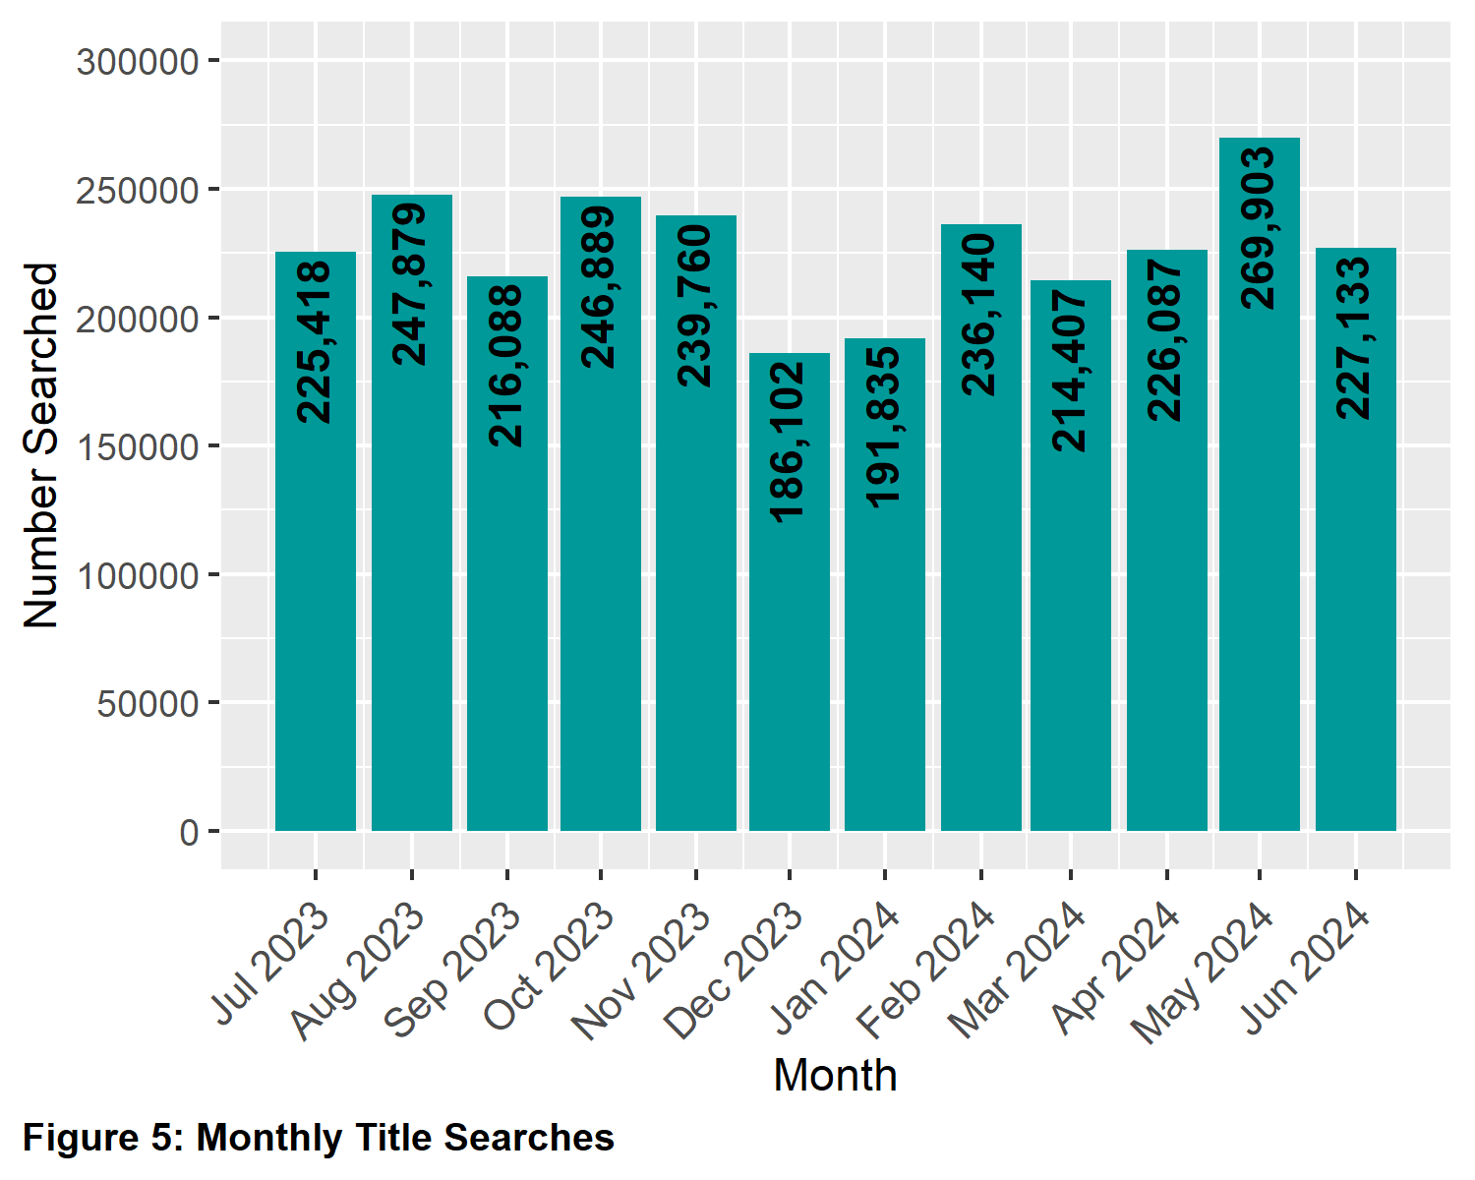

## 2.3 Planning certificates

Planning certificates increased by 18.02 per cent in the 2023-2024 financial year.

| Year | Quantity | Year | Quantity |
| --- | --- | --- | --- |
| **2005-2006** | 37,301 | **2015-2016** | 57,078 |
| **2006-2007** | 33,259 | **2016-2017** | 63,161 |
| **2007-2008** | 40,716 | **2017-2018** | 71,771 |
| **2008-2009** | 32,893 | **2018-2019** | 67,658 |
| **2009-2010** | 37,695 | **2019-2020** | 75,695 |
| **2010-2011** | 37,131 | **2020-2021** | 90,139 |
| **2011-2012** | 38,196 | **2021-2022** | 98,092 |
| **2012-2013** | 42,018 | **2022-2023** | 86,441 |
| **2013-2014** | 50,090 | **2023-2024** | 102,018 |
| **2014-2015** | 55,461 |  |  |
| **Table 3: Number of Planning Certificates  by Financial Year** | | | |

## 2.4 Instrument searches

Instrument searches increased by 8.85 per cent in the 2023-2024 financial year.

| Year | Quantity | Year | Quantity |
| --- | --- | --- | --- |
| **2006-2007** | 587,682 | **2015-2016** | 667,018 |
| **2007-2008** | 613,296 | **2016-2017** | 673,628 |
| **2008-2009** | 618,854 | **2017-2018** | 677,407 |
| **2009-2010** | 757,195 | **2018-2019** | 582,125 |
| **2010-2011** | 721,380 | **2019-2020** | 466,912 |
| **2011-2012** | 668,858 | **2020-2021** | 604,336 |
| **2012-2013** | 683,604 | **2021-2022** | 545,272 |
| **2013-2014** | 682,478 | **2022-2023** | 482,361 |
| **2014-2015** | 667,648 | **2023-2024** | 525,057 |
| **Table 4: Number of Instrument Searches  by Financial Year** | | | |

## 2.5 Property certificates

Property certificates increased by 17.85 per cent in the 2023-2024 financial year.

| Year | Quantity | Year | Quantity |
| --- | --- | --- | --- |
| **2006-2007** | 109,355 | **2015-2016** | 541,176 |
| **2007-2008** | 134,288 | **2016-2017** | 619,212 |
| **2008-2009** | 126,380 | **2017-2018** | 630,885 |
| **2009-2010** | 188,155 | **2018-2019** | 622,465 |
| **2010-2011** | 243,917 | **2019-2020** | 663,119 |
| **2011-2012** | 213,692 | **2020-2021** | 815,614 |
| **2012-2013** | 271,449 | **2021-2022** | 938,347 |
| **2013-2014** | 367,172 | **2022-2023** | 821,604 |
| **2014-2015** | 521,891 | **2023-2024** | 968,283 |
| **Table 5: Number of Property Certificates  by Financial Year** | | | |

## 2.6 Land Index searches

Land Index searches increased by 1.27 per cent in the 2023-2024 financial year.

| Year | Quantity | Year | Quantity |
| --- | --- | --- | --- |
| **2006-2007** | 1,466,544 | **2015-2016** | 1,153,439 |
| **2007-2008** | 1,488,230 | **2016-2017** | 1,345,345 |
| **2008-2009** | 1,278,727 | **2017-2018** | 1,374,961 |
| **2009-2010** | 1,137,876 | **2018-2019** | 1,319,785 |
| **2010-2011** | 1,103,887 | **2019-2020** | 1,352,415 |
| **2011-2012** | 1,053,140 | **2020-2021** | 1,440,211 |
| **2012-2013** | 1,056,131 | **2021-2022** | 1,618,908 |
| **2013-2014** | 998,803 | **2022-2023** | 1,704,251 |
| **2014-2015** | 1,070,323 | **2023-2024** | 1,725,930 |
| **Table 6: Number of Land Index Searches  by Financial Year** | | | |

# 3 Lodgment and Support Services 1 (LSS1)

This statistic refers to services provided to Electronic Lodgment Networks (ELN) on the creation of a workspace. The service, known as LSS1 provides pre-population of title data, title activity checks and lodgment verification. The statistic below shows the number of LSS1s which is directly related to the number of workspaces created.

| Year | Quantity |
| --- | --- |
| **2019-2020** | 476,167 |
| **2020-2021** | 528,675 |
| **2021-2022** | 570,488 |
| **2022-2023** | 553,606 |
| **2023-2024** | 536,442 |
| **Table 7: Number of Lodgment and Support Services 1 (LSS1)**  **by Financial Year** | |

## 3.1 Landata statistics with trend lines

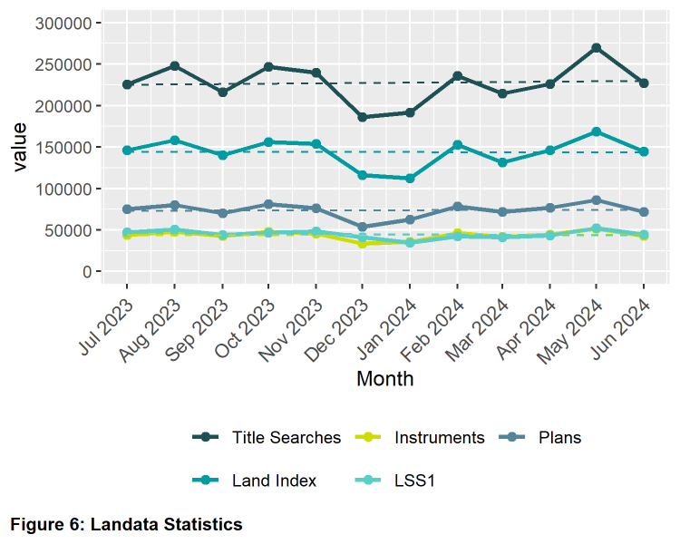

# 4 Water Register

The number of water share transactions decreased by 21.78 per cent in the 2023-2024 financial year. This compares to previous years as follows:

| Year | Quantity | Year | Quantity |
| --- | --- | --- | --- |
| **2007-2008** | 5,259 | **2016-2017** | 6,162 |
| **2008-2009** | 13,391 | **2017-2018** | 9,648 |
| **2009-2010** | 10,983 | **2018-2019** | 11,876 |
| **2010-2011** | 9,990 | **2019-2020** | 7,491 |
| **2011-2012** | 9,871 | **2020-2021** | 7,083 |
| **2012-2013** | 8,800 | **2021-2022** | 8,195 |
| **2013-2014** | 7,529 | **2022-2023** | 9,368 |
| **2014-2015** | 7,670 | **2023-2024** | 7,328 |
| **2015-2016** | 7,013 |  |  |
| **Table 8: Number of Water Share Records Searches  by Financial Year** | | | |

## 4.1 Water share transactions

The Water Registrar is responsible for the recording of transactions on water shares under the Water Act 2007. For the 2023-2024 financial year there was a significant increase in the volume of transactions generated by the creation of new water shares under the Irrigator’s Share Distribution Scheme.

|  |  |
| --- | --- |
| **Transfers** |  |
| Transfer within authority (including limited term transfers) | 2,283 |
| Transfer between authority (including limited term transfers) | 153 |
| **Total Transfers** | **2,436** |
| **Party amendments** |  |
| Address amendment | 3,640 |
| Name and address amendment | 0 |
| Party merge | 0 |
| **Total Party Amendments** | **3,640** |
| **Mortgages** |  |
| Mortgage create | 205 |
| Mortgage discharge | 711 |
| Mortgage variation | 0 |
| Mortgage amendment | 4 |
| Mortgage priority | 0 |
| Create MCP | 6 |
| **Total Mortgages** | **926** |
| **Survivorships** |  |
| Recording of LPR | 167 |
| Recording of survivorship | 143 |
| Recording of trustee in Bankruptcy | 3 |
| **Total Survivorships** | **313** |
| **Registrar notification on water share** |  |
| Create notification | 0 |
| Remove notification | 13 |
| **Total Notifications** | **13** |
| **Table 9: Number of Water Share Transactions Recorded  (Financial Year 2023-2024)** | |

# 5 Lodgment by specific dealing types

## 5.1 Discharges of mortgage

For the 2023-2024 financial year, discharges of mortgage were 33.18 per cent of all dealings lodged.

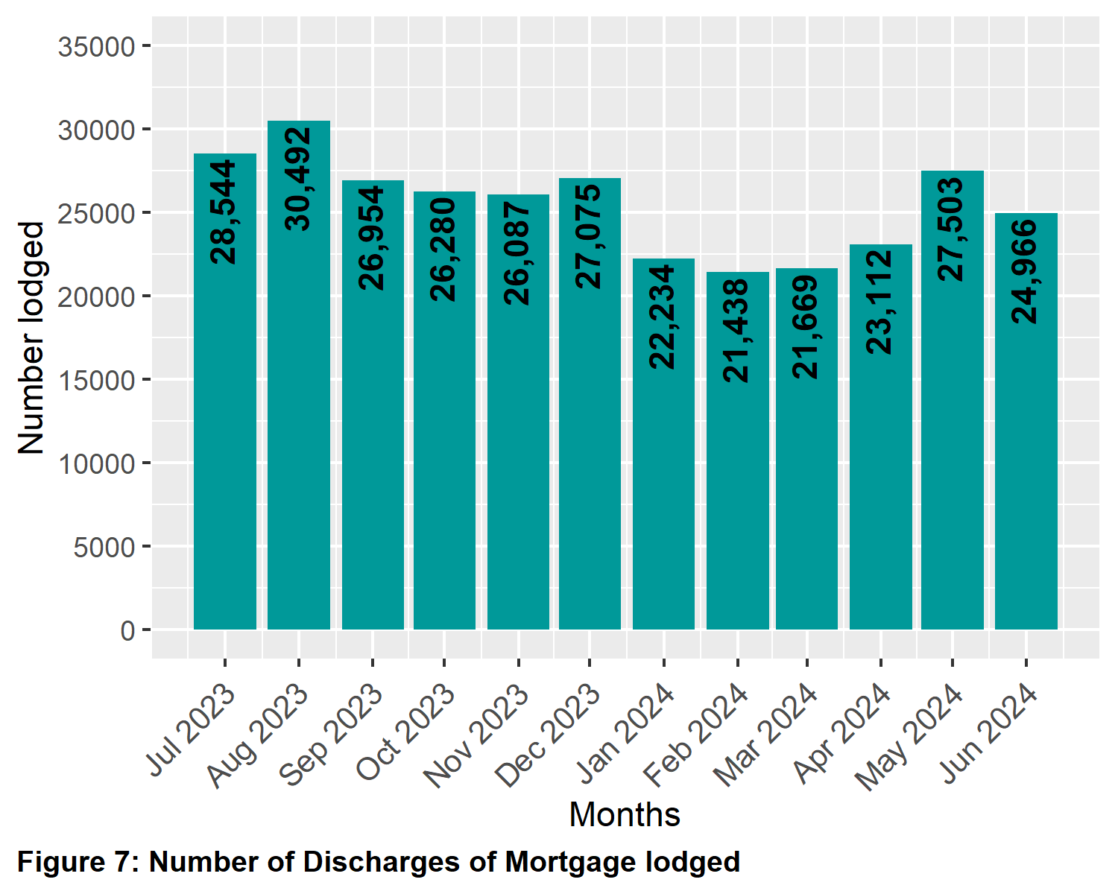

## 5.2 Transfers of land

For the 2023-2024 financial year, transfers for both monetary and non-monetary consideration were 22.4 per cent of all dealings lodged.

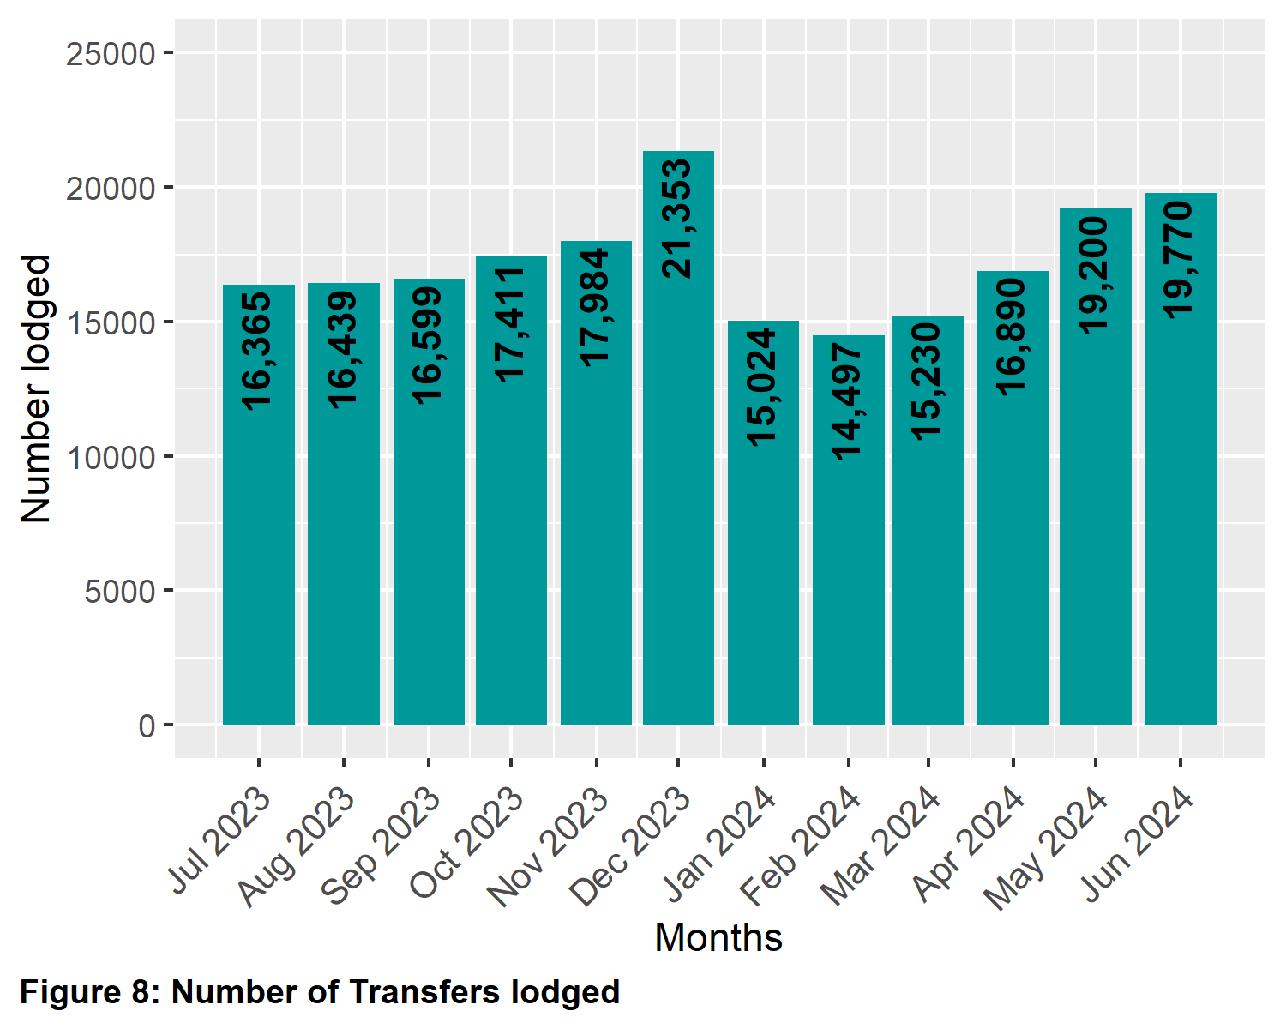

## 5.3 Mortgages

For the 2023-2024 financial year, mortgages and charges were 32.26 per cent of all dealings lodged.

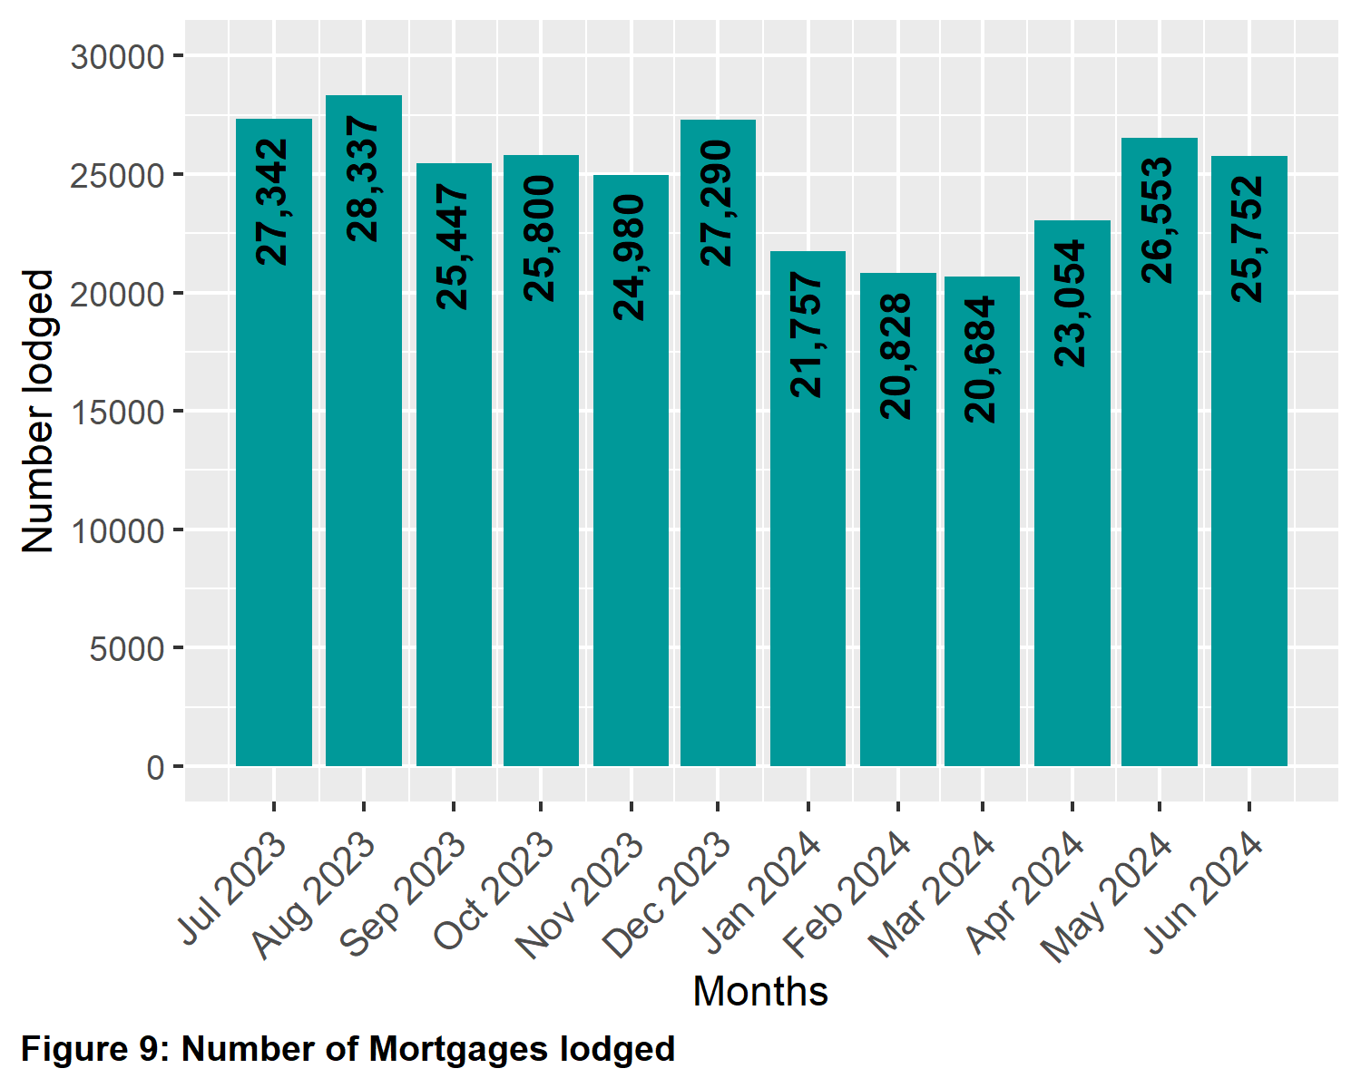

## 5.4 Differences in lodging levels and percentages of discharges, transfers, and mortgages

Over time, the number and relative percentages in the lodgment levels of the three most common transactions vary. These variations are shown below. The average for each of the dealing types for this financial year is as follows:

| Dealing type | Percentage |
| --- | --- |
| **Transfers** | 22.4 |
| **Discharges** | 33.18 |
| **Mortgages** | 32.26 |
| **Table 10: Percent of Dealing Types Lodged  (Financial Year 2023-2024)** | |

The three main dealing types as a percentage of all dealings lodged since 2004-2005 is shown below.

| Year | Transfers (%) | Discharges (%) | Mortgages (%) |
| --- | --- | --- | --- |
| **2004-2005** | 25.05 | 29.53 | 26.75 |
| **2005-2006** | 25.49 | 28.36 | 30.51 |
| **2006-2007** | 25.87 | 28.13 | 29.85 |
| **2007-2008** | 26.27 | 27.59 | 29.19 |
| **2008-2009** | 25.95 | 27.21 | 28.42 |
| **2009-2010** | 26.87 | 27.16 | 28.62 |
| **2010-2011** | 26.22 | 27.20 | 27.68 |
| **2011-2012** | 25.24 | 28.28 | 28.05 |
| **2012-2013** | 25.04 | 28.15 | 27.80 |
| **2013-2014** | 25.76 | 28.54 | 27.74 |
| **2014-2015** | 25.44 | 29.15 | 28.25 |
| **2015-2016** | 23.90 | 29.90 | 29.20 |
| **2016-2017** | 28.05 | 30.60 | 28.69 |
| **2017-2018** | 25.90 | 30.57 | 28.66 |
| **2018-2019** | 23.03 | 29.22 | 27.72 |
| **2019-2020** | 23.72 | 31.98 | 30.80 |
| **2020-2021** | 25.75 | 33.35 | 33.25 |
| **2021-2022** | 25.24 | 32.65 | 32.44 |
| **2022-2023** | 21.02 | 34.37 | 32.98 |
| **2023-2024** | 22.40 | 33.18 | 32.26 |
| **Table 11: Percent of Dealing Types Lodged by Financial Year** | | | |

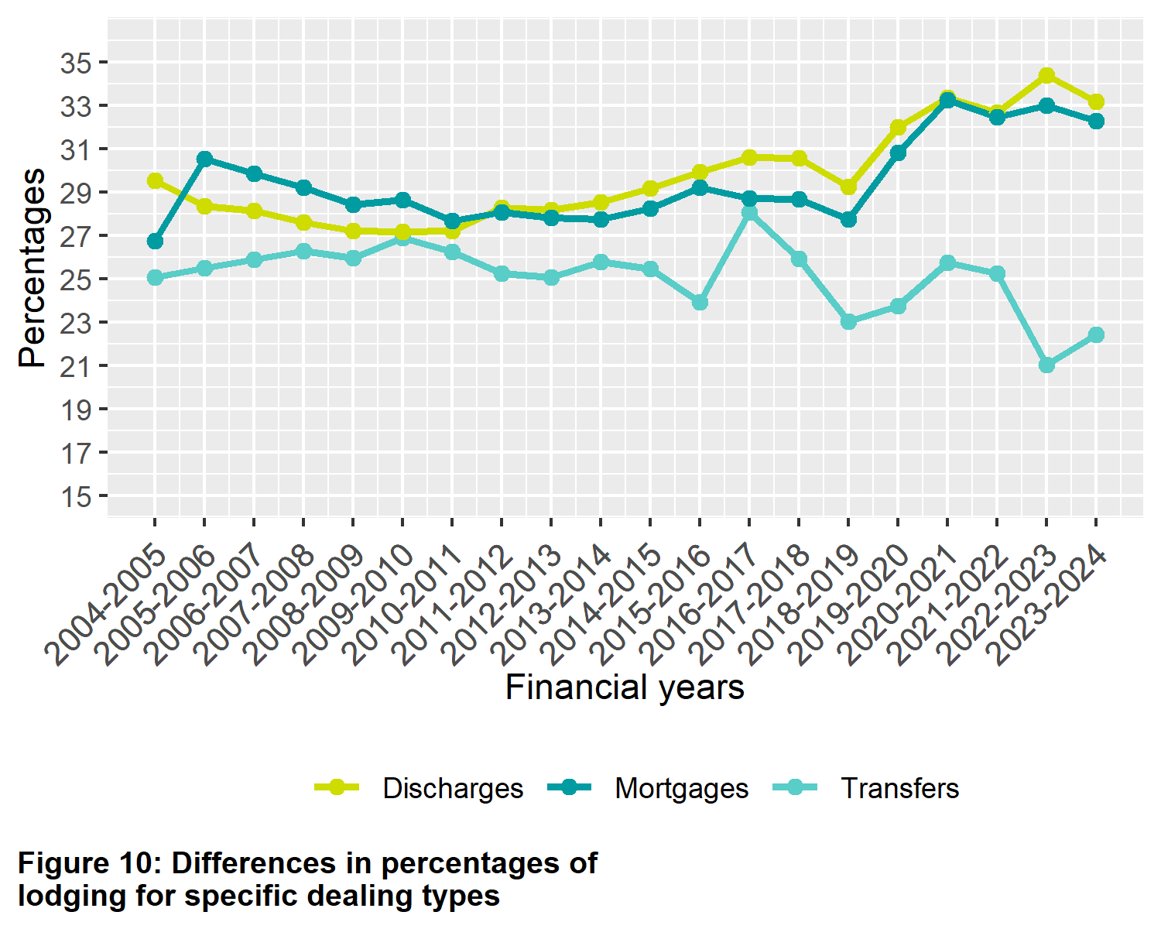

**Figure 10: Differences in percentages of lodging for specific dealing types**

## 5.5 Plans of subdivisions

There were 6,600 plans of subdivision lodged in the 2023-2024 financial year, representing 0.71 per cent of all dealings lodged. There are a range of other plan types that are lodged under the *Subdivision Act 1988* that are not included here including acquisition plans and redevelopment plans. In the 2023-2024 financial year there were 109 of acquisition plans lodged and 196 redevelopment plans.

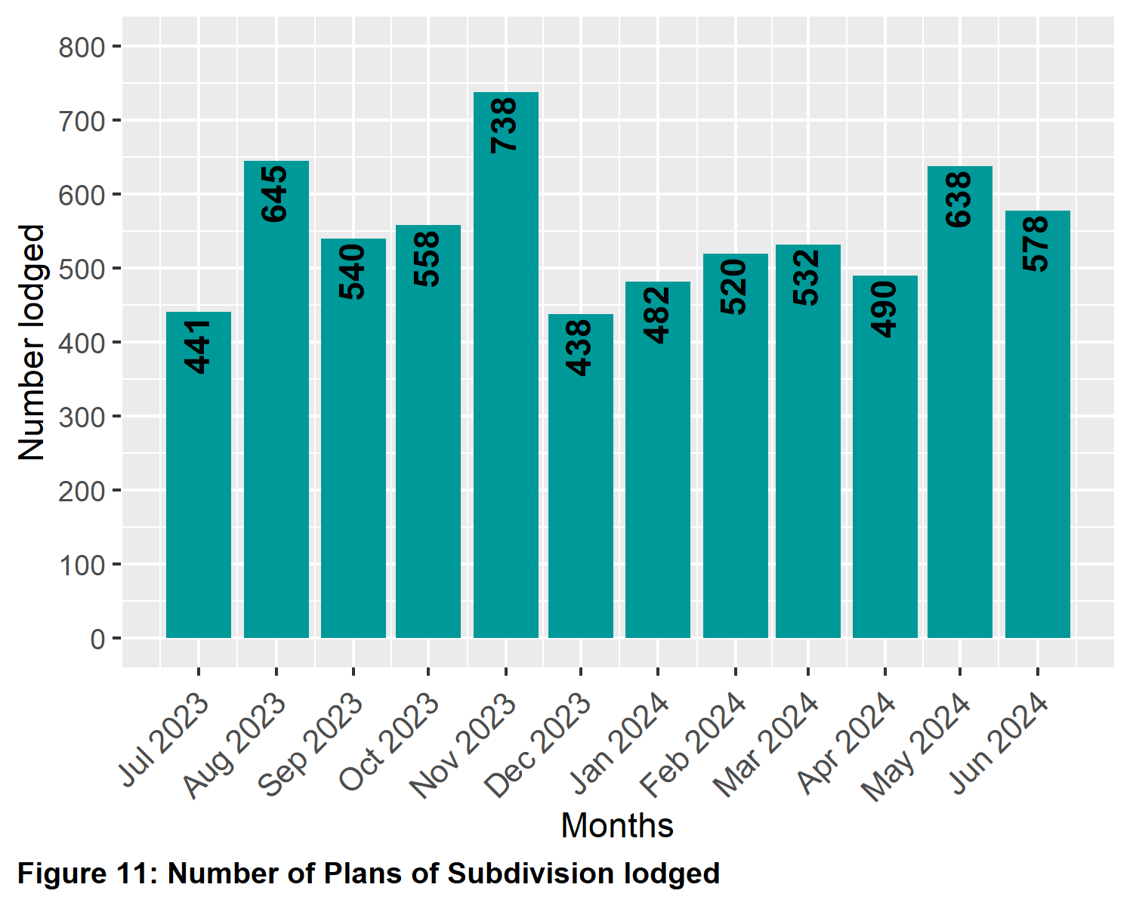

## 5.6 All Plans lodged under the Subdivision Act 1988

The number of plans under the *Subdivision Act 1988* lodged for the 2023-2024 financial year was 7,019. Recent financial year’s lodgings have been:

| Year | Quantity | Year | Quantity |
| --- | --- | --- | --- |
| **2004-2005** | 8,349 | **2014-2015** | 8,252 |
| **2005-2006** | 8,547 | **2015-2016** | 8,970 |
| **2006-2007** | 8,304 | **2016-2017** | 8,376 |
| **2007-2008** | 8,048 | **2017-2018** | 8,340 |
| **2008-2009** | 7,719 | **2018-2019** | 8,249 |
| **2009-2010** | 7,988 | **2019-2020** | 8,541 |
| **2010-2011** | 7,699 | **2020-2021** | 8,220 |
| **2011-2012** | 8,088 | **2021-2022** | 7,536 |
| **2012-2013** | 7,896 | **2022-2023** | 7,064 |
| **2013-2014** | 8,001 | **2023-2024** | 7,019 |
| **Table 12: Number of Plans Lodged by Financial Year** | | | |

## 5.7 Number of new parcels created from plans of subdivision

For the 2023-2024 financial year to date, 61,066 parcels have been created from plans of subdivision under the *Subdivision Act 1988*. The comparison of parcels created from plans of subdivision lodged under Section 22 of the Subdivision Act, which are not related to acquisition, redevelopment, or consolidation, in previous financial years is as follows:

| Year | Quantity | Year | Quantity |
| --- | --- | --- | --- |
| **2014-2015** | 61,669 | **2019-2020** | 82,898 |
| **2015-2016** | 75,351 | **2020-2021** | 74,352 |
| **2016-2017** | 79,034 | **2021-2022** | 60,803 |
| **2017-2018** | 77,014 | **2022-2023** | 67,021 |
| **2018-2019** | 77,602 | **2023-2024** | 59,959 |
| **Table 13: Number of New Parcels Created from Section 22 Subdivisions**  **by Financial Year** | | | |

Note: this figure was incorrectly reported as 68,414 in the table in FY 2022-23 report. 68,414 was inclusive of all plans of subdivision under the Subdivision Act 1988.

## 5.8 General law conversion

The number of parcels created from General law conversions for the 2023-2024 financial year was 373. This compares to previous financial years as follows:

| Year | Quantity | Year | Quantity |
| --- | --- | --- | --- |
| **2004-2005** | 1,750 | **2014-2015** | 2,018 |
| **2005-2006** | 1,490 | **2015-2016** | 2,868 |
| **2006-2007** | 1,309 | **2016-2017** | 3,228 |
| **2007-2008** | 1,238 | **2017-2018** | 1,922 |
| **2008-2009** | 1,023 | **2018-2019** | 1,575 |
| **2009-2010** | 1,559 | **2019-2020** | 1,468 |
| **2010-2011** | 2,559 | **2020-2021** | 482 |
| **2011-2012** | 1,303 | **2021-2022** | 378 |
| **2012-2013** | 1,997 | **2022-2023** | 409 |
| **2013-2014** | 3,774 | **2023-2024** | 373 |
| **Table 14: Number of Parcels Created from General Law Conversions**  **by Financial Year** | | | |

## 5.9 Crown Land Dealings

The number of Crown land dealings registered for the 2023-2024 financial year was 1,550. Transactions are typically related to changes of boundaries and changes to status of Crown land. This compares to previous years as follows:

| Year | Quantity |
| --- | --- |
| **2019-2020** | 1,707 |
| **2020-2021** | 1,346 |
| **2021-2022** | 1,337 |
| **2022-2023** | 1,736 |
| **2023-2024** | 1,550 |
| **Table 15: Number of Crown Land Dealings Registered  by Financial Year** | |

## 5.10 Top 40 dealing types, by number lodged

Shown below are the top 40 dealing types lodged in Land Registry Services for the financial year.

| Dealing type | Description | Lodged |
| --- | --- | --- |
| **84M** | Discharge of mortgage | 306,354 |
| **74** | Mortgage | 289,592 |
| **45** | Transfer | 184,497 |
| **89** | Caveat | 34,737 |
| **45NM** | Transfer without monetary consideration | 22,265 |
| **89W** | Withdrawal of Caveat | 17,529 |
| **49** | Transmission Application | 15,267 |
| **50** | Survivorship Application | 11,619 |
| **74D** | Mortgage with name change | 8,232 |
| **PS** | Plan of Subdivision | 6,600 |
| **31** | Application to replace lost Certificate of Title | 3,348 |
| **173** | Planning Agreement | 2,248 |
| **PN** | Priority Notice | 1,260 |
| **27A** | Change of proprietor name | 1,137 |
| **LTD** | Discharge of land tax charge | 974 |
| **LTC** | Land tax charge | 942 |
| **89A** | Removal of caveat | 832 |
| **MCP** | Memorandum of Common Provisions | 746 |
| **PC** | Plan of consolidation | 605 |
| **77** | Transfer by Mortgagee | 526 |
| **113A** | Amendment of address on folio | 513 |
| **45E** | Creation of easement | 466 |
| **106C** | Removal of encumbrance | 437 |
| **47MSA** | Removal of encumbrance | 412 |
| **32-2** | Application for a new folio of the Register | 408 |
| **52-2** | Warrant | 351 |
| **106AR** | Registrar’s caveat | 342 |
| **RGCAV** | Action - Registrar's Caveat | 334 |
| **45N** | Transfer with new title | 318 |
| **60** | Adverse Possession | 313 |
| **54** | Acquisition by authority | 303 |
| **45M** | Transfer of Mortgage | 290 |
| **SACA** | Change of address of owners corporation | 290 |
| **183W** | Removal of Planning Agreement | 260 |
| **75A** | Variation of Mortgage | 259 |
| **32-1** | Application for a new folio of the Register | 226 |
| **OCAI** | Owners Corporation additional information | 210 |
| **SA32PS** | Plan of Subdivision X32 | 196 |
| **OCR** | Owners Corporation rules | 194 |
| **14** | Non-survey conversion | 187 |
| **Table 16: Top 40 Dealing Types Lodged (Financial Year 2023-2024)** | | |

# 6 Other measures of Land Registry Services activity

## 6.1 Number of dealings registered

The number of transactions registered in the 2023-2024 financial year was 919,297.

## 6.2 Percentage of dealings registered within 5 days

The average percentages achieved were greater than 99 per cent for the whole of the financial year.

## 6.3 Number of plans of subdivision registered

The number of plans of subdivision under the *Subdivision Act 1988* registered for the financial year was 6,919. The average percentage of plans registered within 15 days was 95.73 per cent for the whole of the financial year.

## 6.4 Number of dealings refused

The number of dealings refused for this financial year was 4,831. This represents 0.52 per cent of total dealings presented for acceptance at Land Registry Services for the financial year. In the 2022-23 financial year the figure was 6,217. This represents 0.65 per cent of total dealings presented for acceptance at Land Registry Services.

## 6.5 Number of dealings waiting to be processed

The number of dealings waiting to be processed in this financial year has stabilised. The ‘holding level’ at the commencement of the financial year was 3,051. For the majority of this year that figure has been less than 2,869. The majority, if not all of these dealings, will be in a processing state that requires attention from customers, or cannot be processed until a statutory period has elapsed. As of 1 July 2024 the figure was 2,768.

# 7 Electronic transactions processing

## 7.1 Electronic Conveyancing

The number of transactions lodged electronically in the 2023-2024 financial year was 901,838, down from 924,889 in 2022-23. Transactions lodged electronically in 2023-2024 financial year accounted for 97.68 per cent of all lodgments compared with 97.2 per cent in the previous financial year. For 2023-2024, this was made up of the following:

| Transaction Type | Quantity |
| --- | --- |
| **Discharge of Mortgage** | 305,341 |
| **Mortgage** | 297,393 |
| **Transfer** | 205,110 |
| **Caveat** | 34,400 |
| **Withdrawal of Caveat** | 17,388 |
| **Transmission Application** | 15,093 |
| **Survivorship Application** | 11,356 |
| **Application Lost Title** | 3,245 |
| **Agreement** | 2,176 |
| **Priority Notice** | 1,260 |
| **Discharges of Land Tax Charges** | 974 |
| **Land Tax Charges** | 942 |
| **Removal of Caveat** | 808 |
| **Transfer by Mortgagee** | 520 |
| **Application for New Folio** | 466 |
| **Warrant** | 407 |
| **Transfer of Mortgage** | 273 |
| **Statutory Charge** | 191 |
| **Withdraw Priority Notice** | 120 |
| **Discharge of Charge** | 16 |
| **Miscellaneous** | 4,359 |
| **Table 17: Number of Transactions Lodged Electronically  by Type (Financial Year 2023-2024)** | |

## 7.2 Percentage of transactions lodged electronically

