Product Description

Vicmap Elevation 1m DEM

Version 1.0 June 2024
AS/NZS ISO 19131:2008 compliant

Document Control
Version | Date | Note
0.1 | November 2022 | First Draft.
0.2 | March 2023 | Adoption of DTP template and badging. Format and content based on Vicmap LiDAR DEMs and Vicmap LiDAR Points Collection Product Descriptions.
0.3 | March 2024 | Refinement of content based on progress towards published web services.
1.0 | June 2024 | Version available with public launch of 1m DEM
This document has been formatted and structured as an adaptation to AS/NZS ISO 19131:2008 Geographic Information – Data product specifications.

Table of Contents
Document Control 1
Table of Contents 2
List of Figures 3
List of Tables 3
Overview 4
Vicmap™ 4
Data Product Specification Title 4
Informal Description of the Data Product 4
Related VicmapTM Elevation Products 5
Responsible Party 5
Internet Site for Information 5
Specification Scope 5
Level 5
Extent & Coverage 5
Data Product Identification 6
Title 6
Alternative Title 6
Spatial Representation Type 6
Spatial Resolution 6
Abstract 7
Data Content and Structure 8
Data Content 8
Data Model 8
Data Type 9
Data Structure 9
Reference Systems 10
Horizontal Datum 10
Projection 10
Vertical Datum 10
Data Capture 10
Production Methods 11
Data Quality 13
Accuracy 13
Completeness 14
Logical Consistency 14
Data Maintenance 15
Source Data Maintenance 15
Web Service Maintenance 15
Data Product Delivery 16
Licensing 16
Access 16
Metadata 17

List of Figures

Figure 1: Vicmap 1m DEM Coverage (March 2024) 6
Figure 2: Bridge exclusion from DEM surface 11
Figure 3: Hydro flattened rivers and water bodies 12
Figure 4: Water levels mapped in LiDAR surveys conducted 6 months apart. 14
Figure 5: Rough DEM surface due to “last” LiDAR returns coming from crop surface 15
Figure 6: Canola crop in full bloom and maximum foliar density at time of LiDAR survey 15

List of Tables
Table 1: Vicmap 1m DEM content summary 8
Table 2: Mosaic Footprint Attributes 9
Table 3: Access points for Vicmap 1m DEM 16

Overview

Vicmap™
Vicmap™ is the foundation that underlies most spatial information in Victoria. This portfolio of spatially related authoritative data products, comprising individual datasets, is developed, and managed by the Department of Transport and Planning. The information provides the foundation to Victoria’s primary mapping and spatial information systems and is used for building business information and systems.

Vicmap is a registered trademark of the Victorian Government and has been synonymous with authoritative state-wide mapping since 1975.

Vicmap Catalogue

Data Product Specification Title
Vicmap™ Elevation 1m DEM

Topic Theme
Elevation

Topic Category
Elevation Surface

Informal Description of the Data Product
Vicmap Elevation 1m DEM is a mosaic product of the latest DEM datasets available from the Vicmap Elevation – LiDAR DEMs collection that meet or exceed 1m resolution and +/-10cm RMSE vertical accuracy. As such, Vicmap 1m DEM represents the single most comprehensive and current source of high resolution, high accuracy ground surface data available for Victoria.

Deriving from the Vicmap Elevation LiDAR DEM’s collection, the Vicmap 1m DEM inherits the data characteristics of the source data from the collection. As such data currency varies according to when the latest data was collected for a particular area. See the Vicmap Elevation LiDAR DEM’s Collection production description for a full description of DEM characteristics including treatment of water bodies, river surfaces, bridges, and culverts.

Vicmap Elevation 1m DEM is primarily distributed as web services through a variety of ESRI and OGC interfaces including WMS, WMTS and WCS aimed at supporting as many visualisation and analysis purposes as possible. In addition to the accessibility benefits offered by web services, the Vicmap 1m DEM is published with numerous surface representations including standard monochrome DEM surface and colour hill-shaded surfaces. A physical version of the 1m DEM is also maintained to support physical delivery in cases where the consumption of web-services is not practical.

Related VicmapTM Elevation Products
VicmapTM Elevation – LiDAR DEMs Collection
VicmapTM Elevation – LiDAR Points Collection

Responsible Party
Vicmap Spatial Services Branch
Department of Transport and Planning
GPO Box 2392
Melbourne 3001

vicmap@tansport.vic.gov.au

Internet Site for Information
Vicmap Elevation

Specification Scope
This specification describes the Vicmap Elevation 1m DEM product, which is a mosaic compilation of datasets selected from the Vicmap Elevation LiDAR DEM’s collection and delivered as web services. This document describes the data contributing to the 1m DEM mosaic. Web service descriptions and user guide can be found on the Vicmap 1m DEM web page.

Level
Product

Extent & Coverage
The Vicmap Elevation 1m DEM is dynamic in coverage. At the time of original release in 2024, the available coverage represents approximately 60% of the land area and approximately 98% of the populated areas of Victoria. This coverage reflects the data available in the source Vicmap LiDAR DEM’s collection whose content is driven by purchase partner investment through Victoria’s Coordinated Imagery Program (CIP). As the collection expands, so too will the coverage of data available in the Vicmap 1m DEM. Cross border data supplied by New South Wales State Government has also been incorporated along sections of the Murray River.
A Vicmap 1m DEM Footprints polygon feature layer representing the extents of the source DEM datasets is maintained in synchronisation with updates to the mosaic. The footprints, which are also published as web feature services, provide an explicit record for the data present in the mosaic.

Figure 1: Vicmap 1m DEM Coverage (March 2024)
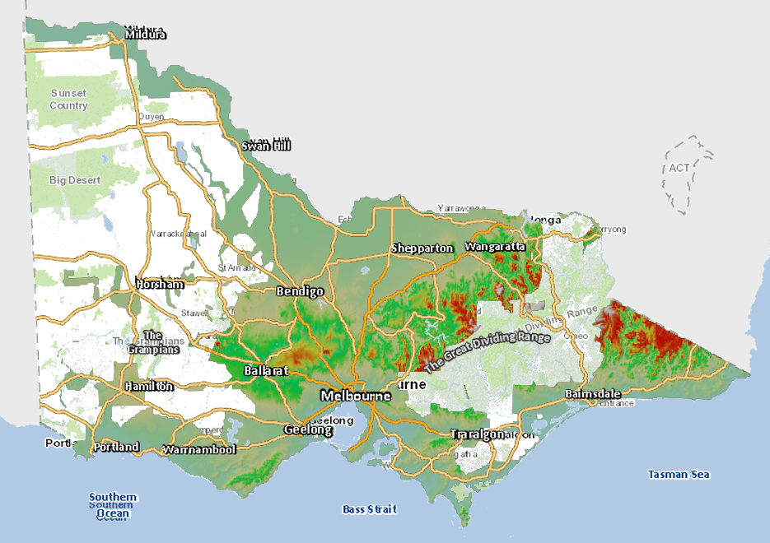

Data Product Identification

Title
Vicmap Elevation 1m DEM

Alternative Title
Vicmap 1m DEM
Vicmap 1-metre Digital Elevation Model

Spatial Representation Type
Raster data
(delivered as web services)

Spatial Resolution
1m

Abstract
Vicmap Elevation 1m DEM is a mosaic compilation of the latest high resolution, high accuracy ground surface DEM data available for Victoria published as spatial web services. Published services include a variety of ESRI image and OGC web service interfaces that will support ground surface analysis, visualisation and use as an underlying terrain surface.
By releasing the Vicmap 1m DEM through spatial web services, users can gain access to the most authoritative terrain data available without relying on keeping a copy of the data themselves. Further, users can trust that the services they're accessing will contain the latest data available. Approximately 0.5 terra bytes of surface data is presently being served in the Vicmap 1m DEM representing significant data storage cost savings for users.
The mosaic draws from Vicmap’s archive of LiDAR derived ground surface models known as the Vicmap LiDAR DEMs Collection. This collection of DEMs has been curated by the CIP since 2006 with the archive growing annually with continued public sector investment and user driven capture. Presently, the collection covers approximately 60% of the land area of the State and 95% of the populated areas of the State.

The qualifying requirements for Vicmap LiDAR DEM datasets used in the Vicmap Elevation 1m DEM are:
- Source Resolution: 1m (or higher)
- Vertical Accuracy: +/- 10cm RMSE
- Currency: latest data available for a given area

Data Content and Structure

Data Content
At the time of original release in 2024, the Vicmap 1m DEM includes 204 separate DEM datasets from the LiDAR DEMs collection. A Vicmap 1m DEM Footprints polygon feature layer representing the extents of the source DEM datasets is maintained in synchronisation with any updates to the mosaic. The footprints, which are also published as web feature services, provide an explicit record for the data present in the mosaic.
Table 1: Vicmap 1m DEM content summary
Feature | Description
Source Data | Vicmap LiDAR DEMs Collection (aerial LiDAR survey)
Resolution | 1m or higher
Currency | Ranging from 2009 to present
Vertical Accuracy | +/-10cm RMSE
Horizontal Datum | GDA2020
Vertical Datum | AHD
Data Format | Cloud Optimised GeoTIFF (COG)
Coordinates | MGA54 and MGA55
Coverage (2024) | 60% of Victoria

Data Model
The Vicmap 1m DEM uses a 1m raster (or grid-cell) data model. For the purposes of inclusion in the 1m DEM mosaic, each contributing source DEM dataset is formatted as a Cloud Optimised GeoTIFF (COG) file where each grid cell represents X,Y location and carries a Z elevation data value. All elevation (Z) values are represented as orthometric (AHD) heights.
Vicmap 1m DEM footprints are also maintained as polygon features with data source name, date, resolution, accuracy and original CIP project reference attribution.

Table 2: Mosaic Footprint Attributes
Field Name | Field Type | Description
Filename | Text,254 | Filename of source raster dataset
Date | Date | Capture start date of source raster dataset
Source_Resolution | Text,10 | Resolution of source raster dataset
Vertical_Accuracy | Text,10 | Vertical Accuracy of source raster dataset
Horizontal_CRS | Integer,10 | Source EPSG code for Horizontal CRS
Vertical_CRS | Integer,10 | Source EPSG code for Vertical CRS
Access | Text,50 | Accessibility of source data
Contact | Text 50 | Website link to obtain data
CIP_code | Text,10 | CIP Project code for source raster dataset
Area_sqkm | Double | Area of source dataset used
Layer_Update | Date | Date Footprints dataset was updated

File naming:
Vicmap 1m DEM web services will utilise the following convention:
<name>_<product><resolution>_<symbology>_v<vertical accuracy>_<v-datum>-<h-projection>
Example: vicmap_dem1m_hillshade_v10cm_ahd-epsg7899

Any physical mosaic versions exported from the virtual mosaic will carry an additional version-date suffix indicating when the file was created.

<name>_<product><resolution>_<symbology>_v<vertical accuracy>_<v-datum>-<h-projection>_<version-suffix>
Example: vicmap_dem1m_hillshade_v10cm_ahd-epsg7899_20240318

Data Type
32-bit gridded/raster floating point data with 2 decimal point precision.

Data Structure
Vicmap 1m DEM web services are published from a virtual mosaic representing a pre-qualified set of source raster datasets. Each source dataset is itself a single (COG) file representing a contiguous, irregular project area. The source DEM datasets are chronologically layered within the virtual mosaic in top-to-bottom order of latest to oldest. As new source datasets become available, they are added to the top of the order. When older datasets are spatially superseded by newer datasets, they are removed from the mosaic. Footprints are maintained in alignment with each mosaic update.

Data Voids
Data voids are not present within the bounds of each contributing source DEM dataset. However, voids may be present in between source datasets, most commonly where older source datasets were created to irregular shaped boundaries. LiDAR derived DEM datasets from 2018 onwards have routinely been created to regularly structured tile indices enabling neat edges between source datasets.

Reference Systems

Horizontal Datum
The source DEM datasets that constitute the Vicmap 1m DEM are all aligned to GDA2020. Early datasets that were originally aligned to older datums (pre-2019) have been transformed to GDA2020. Published web services deliver data on GDA2020 as well as other common datums.

Projection
The source DEM datasets that constitute the Vicmap 1m DEM are projected in either MGA54 or MGA55 according to their location in Victoria. Published web services deliver data in both native projections as well as other common projections.

Vertical Datum
The source DEM datasets that constitute the Vicmap 1m DEM are modelled to the Australian Height Datum (AHD) using the Ausgeoid model that was officially in use at the time of survey. Datasets using earlier than current geoid models have not been re-modelled to AHD. All published web services deliver data referenced to AHD.

Data Capture
The source DEM datasets that constitute the Vicmap 1m DEM derive from LiDAR survey projects undertaken through Victoria’s Coordinated Imagery Program (CIP). LiDAR surveys are conducted on behalf of the State by commercial aerial survey companies that have qualified for the relevant State services panels.
Acquisition planning is driven by purchase partner investment in the CIP program and is implemented in an on-demand basis. Aerial survey most often occurs as a single project achievable within one flying season by a single commercial supplier. As investment and funding allows, larger capture programs may occur that span multiple flying seasons and require multiple commercial suppliers to complete.
LiDAR survey within Victoria is achievable throughout the whole calendar year, however most data capture has been conducted during the spring, summer, and autumn seasons (November through to May).

Production Methods

The source DEM datasets that constitute the Vicmap 1m DEM are constructed from LiDAR points classified as “ground”. The model defines a “bare earth” ground surface and is devoid of trees and human-made structures. In summary terms, the DEM generation approach employs a Point to TIN and TIN to Raster process.

The surface models exclude road and rail bridges as well as major culverts. If these features were incorrectly classified as LiDAR ground points and automatically included in the DEM, they are subsequently edited out of the model in a manner that ensures the underlaying terrain is continuous and not left as a gap or void in the surface.

Figure 2: Bridge exclusion from DEM surface
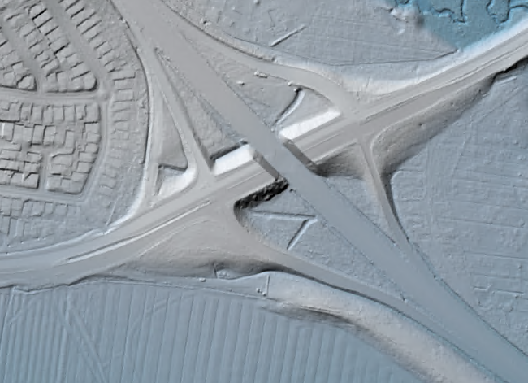

Non tidal water bodies with a surface area in excess of 625m² and major rivers with mean width greater than 30m are represented as flat surfaces within the DEM. Various approaches to hydro flattening have been employed, however all approaches have been based on using the lowest surrounding land elevation values to set the height of the flattened water surface. The result is that the entire water-surface edge is at, or below the immediately surrounding terrain.

Figure 3: Hydro flattened rivers and water bodies
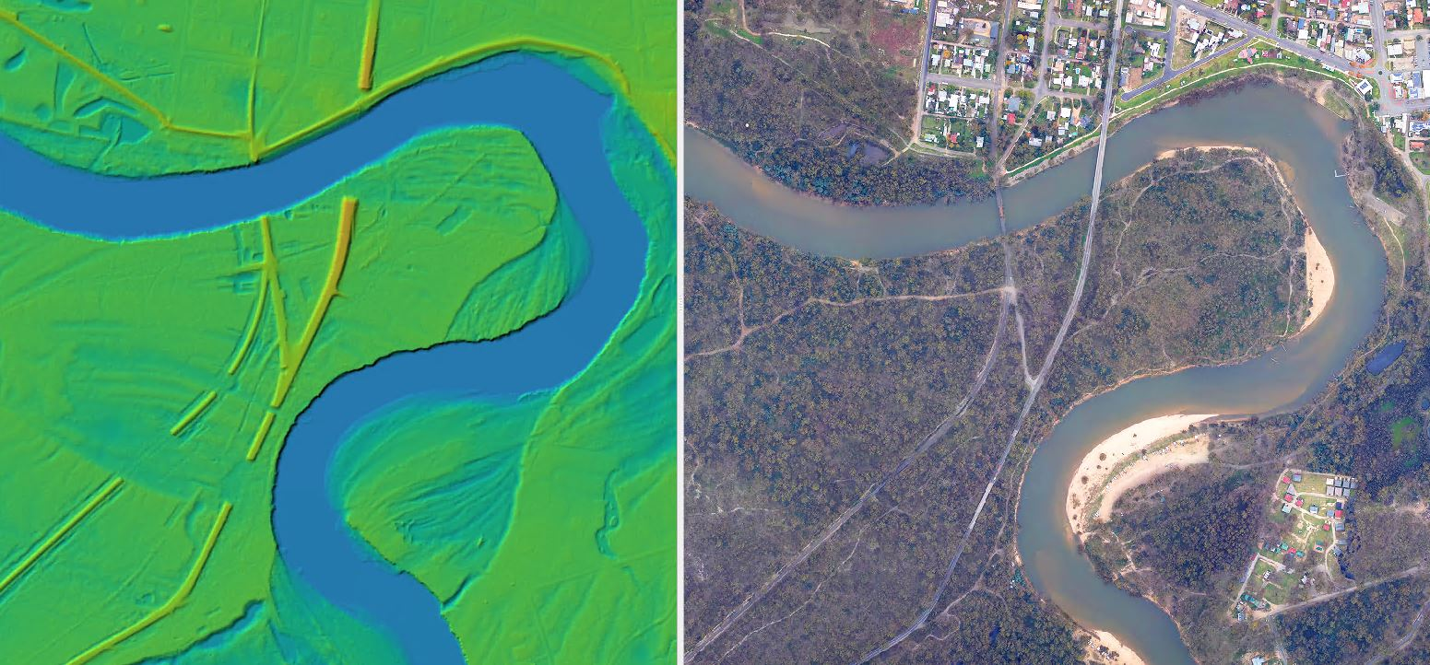

The Vicmap 1m DEM web services are published from a virtual mosaic of the constituent DEM datasets. The virtual mosaic is updated with new data as it becomes available, and the web services immediately reflect the new data.

In general terms, if physical data is required, users will be directed to use the constituent DEM datasets from the Vicmap 1m DEM Collection. However, periodically, physical mosaic versions of the Vicmap 1m DEM may be exported from the virtual mosaic. Although web services are published in various datums and projections, physical mosaics are not exported in anything other than their native GDA2020 datum and projection.

Data Quality
Data quality for the source LiDAR DEMs will vary according to the LiDAR survey specifications and to some extent, the age and date of the source LiDAR survey. In all cases, the LiDAR Point and DEM data products have been verified as meeting the designated specifications for the original survey.
Given there is variation within the Vicmap LiDAR DEMs collection of source datasets, a conditional selection based on three criteria is applied to identify datasets that qualify for inclusion in the Vicmap 1m DEM:

- Source Resolution: 1m (or higher)
- Vertical Accuracy: +/- 10cm RMSE
- Currency: latest data available for a given area

Source datasets whose original resolution is higher than 1m are resampled down to 1m for the purposes of inclusion in the Vicmap 1m DEM. Any source data that is of higher resolution can be accessed through the Vicmap LiDAR DEMs Collection product.

Accuracy

Horizontal Accuracy
Greater than or equal to +/- 30cm RMSE

All LiDAR surveys from which the source DEM datasets are derived are rated at +/-30cm RMSE horizontal accuracy. Greater horizontal accuracies are now achievable and have been demonstrated in more recent LiDAR surveys that have contributed LiDAR DEM datasets.

Vertical Accuracy
+/- 10cm RMSE

The vertical accuracy of the source DEM datasets used in the 1m DEM have been verified against the states Survey Control Network (SCN) as being within the specified +/-10cm RMSE tolerance at the time of the survey.

Spatial Data Integrity
The stated accuracies apply to the data in its native coordinate reference system. Transforming or reprojecting DEMs may alter and reduce the fidelity of the elevation values for the transformed or reprojected coordinate. Web services that are published in alternate coordinate reference systems from the source data should always be consumed with this understanding in mind.

Geoid Models
The representation of DEM elevations on AHD is affected by the quality of the Geoid Model used to transform the original ellipsoidal elevation. Older source DEM datasets have been modelled to AHD using different geoid model versions including Ausgeoid94, Ausgeoid09 and presently, Ausgeoid2020. More recent LiDAR derived source DEM datasets will have benefited from gradual improvements in the geoid model over time.

Edge Matching
Although not possible to guarantee, source DEM datasets used in the Vicmap 1m DEM should vertically align with adjacent and overlapping datasets within the range of their respective vertical tolerances or accuracies. Older DEMs are less likely to agree with newer DEMs and this is due to the reasons described in the Vertical Accuracy section. Since the advent of GDA2020 and the Ausgeoid2020 model for AHD, the State has introduced the practise of supplying survey control to its commercial aerial survey contractors. This strategy allows the State to ensure consistently high accuracy, high-quality ground control data is used across all LiDAR surveys, and this has resulted in excellent vertical alignment across LiDAR surveys conducted by different contractors.

Completeness
At time of launch, the Vicmap 1m DEM covers approximately 60% of the States land area. Coverage will expand as new LiDAR surveys are conducted in areas not previously covered.

Logical Consistency
The source DEM datasets are all consistent in their representation of elevation data relative to AHD. However, variations do exist in the age of the source datasets and due to the evolution of surface modelling approaches and geoid model accuracies over time, there may be differences in the texture and detail of the ground surface representation or variations in apparent vertical accuracy.
Some of the most obvious variations in ground surface representation will be the manner in which water bodies have been hydro flattened and bridges treated, particularly between older and newer source DEM datasets.
Figure 4: Water levels mapped in LiDAR surveys conducted 6 months apart.
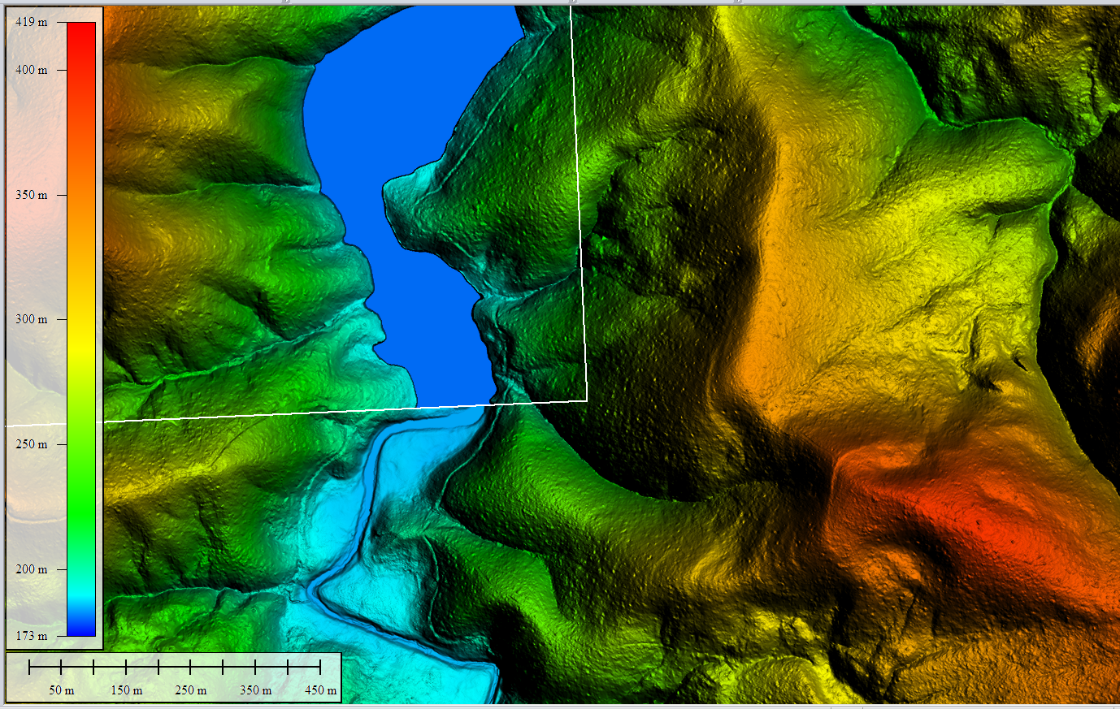
October 2023

April 2023

Another well-known LiDAR derived ground surface phenomenon is the occasionally unreliable ground surface representation under crops surveyed at phenological stages where the vegetation is thick and largely impenetrable to laser pulses. In the following example (Figures 5 and 6), the ground surface roughness results from lack of LiDAR penetration through a dense Canola crop providing insufficient ground strikes to delineate the ground surface reliably. In the crops such as these, the detail within the ground surface is considered dynamic as it changes every time the crop is harvested and replanted.

Figure 5: Rough DEM surface due to “last” LiDAR returns coming from crop surface | Figure 6: Canola crop in full bloom and maximum foliar density at time of LiDAR survey
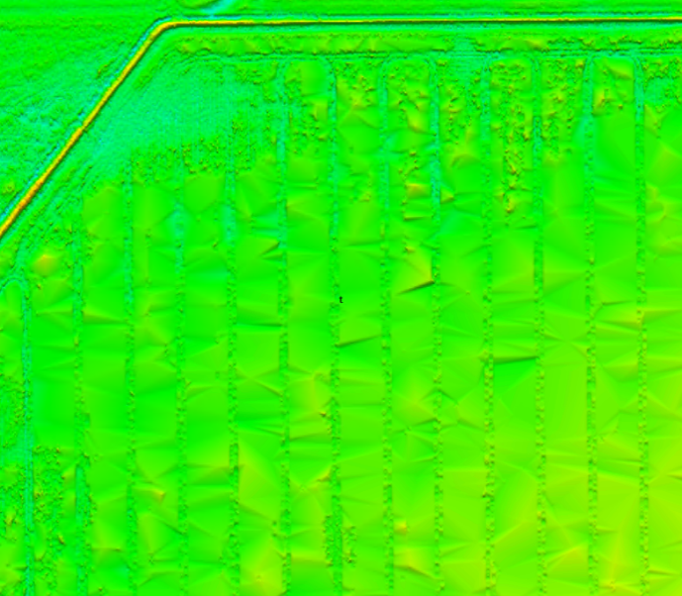 | 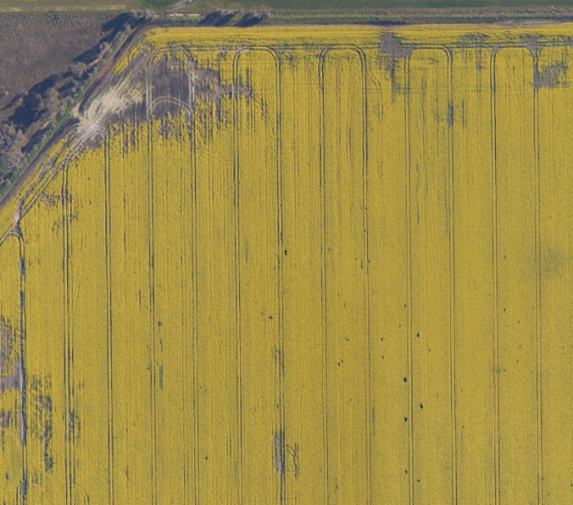

Data Maintenance

Source Data Maintenance
Vicmap 1m DEM is derived from DEM datasets available in the Vicmap LiDAR DEMs collection. The collection will continue to grow with each aerial LiDAR survey undertaken by the Coordinated Imagery Program (CIP); however, this occurs in an unplanned manner driven by the requirements of investing purchase partners. Data maintenance will continue to be driven by those agencies that fund LiDAR surveys for their project purposes.

Web Service Maintenance
Vicmap 1m DEM web services will be maintained with the newest qualifying content from the Vicmap LiDAR DEMs collection as that data becomes available. Users can expect the data content in the web services to be a current reflection of what is available.

Data Product Delivery

Licensing
Vicmap 1m DEM is subject to licensed use. Data Access License Agreements (DALA) provide the terms and conditions of use, including license fees.

Commercial use licenses may also be negotiated with businesses wishing to become a licensed Value-Added Reseller (VAR) or licensed Data Service Provider (DSP).

Please see the Vicmap 1m DEM web page for further licensing details.

Access
Table 3: Access points for Vicmap 1m DEM
Discover Vicmap 1m DEM
Footprints | Vicmap 1m DEM footprints are published as open web service (WFS) and not subject to licensed use. The footprints can be discovered on the Vicmap Elevation web page, via the Digital Twin Victoria (DTV) platform or physically downloaded from Data.Vic.
Web Services | Descriptions of the available Vicmap 1m DEM web services can be found on the Vicmap Elevation web page
Sample Web Service | The Sample Web Service is a full resolution version of the Vicmap 1m DEM over limited areas of the state. designed to facilitate a visual preview of the data available in the 1m DEM before purchasing a license. Users wishing to utilise the Free View service in an ongoing or operational capacity should purchase a license to the Vicmap 1m DEM. The Free View web service can be viewed from the Vicmap Elevation web page or via the Digital Twin Victoria (DTV) platform.
Where to Purchase Licensed Access
Please see the Vicmap 1m DEM web page for further licensing details.

Metadata
There are three levels of metadata available in relation to the Vicmap 1m DEM.

- Product description
This document describes the Vicmap 1m DEM product as a collated mosaic of the latest available ground surface data for Victoria.

- 1m DEM footprints
Paired with the published Vicmap 1m DEM raster data is a set of polygon footprints representing the boundaries and key metadata attributes of the source DEM datasets currently contained the 1m DEM.

- 1m DEM web services descriptions
The Vicmap 1m DEM User Guide provides details of the variety of web services and available interfaces, including connection instructions. Please see the Vicmap 1m DEM web page to access the User Guide.

