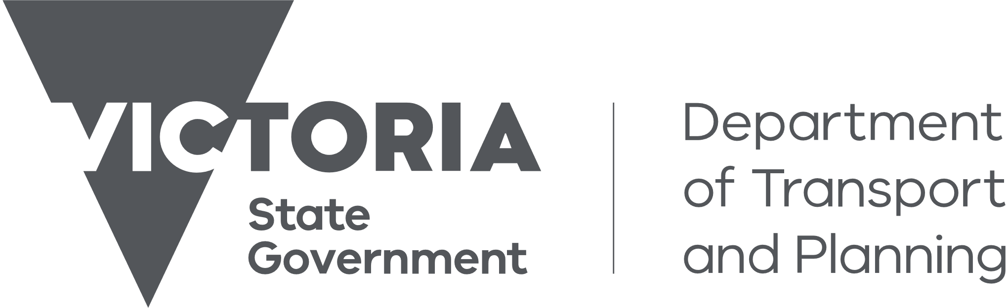

Customer Information Bulletin 229

July 2024

# Reminder: Phasing out of paper certificates of title

## Changes to new certificates of title in Victoria from 3 August 2024

Since 2000, Victoria has been on a journey to create a future-ready Register of land. Electronic certificates of title (eCTs), verification of identity, client authorisation, certifications and priority notices are now well established.

Phasing out paper certificates of titles (pCTs) is the next step in the journey to streamline and modernise Victoria’s land administration.

From 3 August 2024, all new Victorian certificates of title from the Register of land will be electronic.

Existing paper certificates of title will remain valid until they are next required for a land transaction.

Please refer to the [Phasing out of Paper Certificates](https://www.land.vic.gov.au/land-registration/for-individuals/the-victorian-register-of-land/phasing-out-paper-certificates-of-title) page for further information.

## Processing cut-off times for paper certificates of title

It is important to note that the change will take effect based on the **registration date** of an instrument, **not the lodgment date**.

Subscribers who have selected paper in the issuing instructions will receive paper certificates if they are lodged and registered before 3 August 2024.

Any instruments that are registered on or after 3 August 2024 and require the issue a certificate of title, will result in an electronic certificate, regardless of the lodgment date.

Most electronic instruments, such as transfers, mortgages, discharge of mortgage, caveats, withdrawals of caveats, transmission and survivorship applications, are electronically examined and registered or recorded very soon after lodgment. In some cases, they require manual examination, so additional time is required.

Once the change takes effect, paper will no longer be an available format in the "Issuing Instructions" section within an ELNO (PEXA and Sympli). As of 3 August 2024, the only available format will be electronic.

Instruments submitted through the Generic Residual Document are processed manually, so additional time is required. The date a Generic Residual Document is submitted using the ELN is not the date of lodgment.

Generic Residual Document submissions received after 26 July 2024 may not result in a paper certificate of title (if one is required) being issued as the instrument(s) lodged may be registered after 3 August 2024.

More information about Generic Residual Document lodgments can be found on the [Electronic submission of paper instruments](https://www.land.vic.gov.au/land-registration/for-professionals/our-electronic-lodgment-program/electronic-submission-of-paper-instruments) page on our website.

## Further information

To learn more about these changes, please visit the [Land.Vic website](https://www.land.vic.gov.au/land-registration/for-individuals/the-victorian-register-of-land/phasing-out-paper-certificates-of-title) for more information and common questions that may arise. The [Guide to Certificates of Title and Administrative Notices](https://www.land.vic.gov.au/__data/assets/word_doc/0030/711498/Guide-to-Certificates-of-Title-and-Administrative-Notices-July-2024.docx) for professionals has been updated and can be found at: [Fees, Guides and Forms](https://www.land.vic.gov.au/land-registration/fees-guides-and-forms).

To help explain these changes to clients, we have also created a video on certificates of title and this change. Visit the [Land.Vic website](https://www.land.vic.gov.au/land-registration/for-individuals/the-victorian-register-of-land/phasing-out-paper-certificates-of-title) to view the video.

Useful website links:

* [The Victorian Register of land](https://www.land.vic.gov.au/land-registration/for-individuals/the-victorian-register-of-land/phasing-out-paper-certificates-of-title)
* [Phasing out paper certificates of title](https://www.land.vic.gov.au/land-registration/for-individuals/the-victorian-register-of-land/phasing-out-paper-certificates-of-title)
* [CIB 223 – New Administrative Notices](https://www.land.vic.gov.au/land-registration/customer-information-bulletins/2023/223)
* [Guide to Certificates of Title and Administrative Notices](https://www.land.vic.gov.au/__data/assets/word_doc/0030/711498/Guide-to-Certificates-of-Title-and-Administrative-Notices-July-2024.docx)

This transition involves coordination with all parts of the electronic conveyancing process to align systems, update practices and adopt change. We value the continued engagement with industry to support progress in electronic ways of working.

If you have questions or require further assistance, please contact us. For queries relating to phasing out of pCTs, please submit your enquiry with as much detail as possible using the [online form](https://servictoria.com.au/contact/submit-an-enquiry/) provided by SERV.

# Stay up to date with CIBs

We publish customer information bulletins (CIBs) to let you know about new procedures and updates on Land Registry Services. These updates are important as they often supersede information in earlier guides and bulletins.

To receive a notification when a new customer information bulletin is published, please [visit our sign up page](https://www.land.vic.gov.au/land-registration/customer-information-bulletins/sign-up-for-bulletins).

# Contact us

For location and contact details, please go to <http://www.land.vic.gov.au/contact-us>.