SouthPAN
Improved GPS positioning accuracy and integrity
Southern Positioning Augmentation Network (SouthPAN)
SouthPAN is a new, open access GPS correction service being established by the Australian and New Zealand governments to improve GPS positioning across our shared region. It is part of a broader national positioning program that will enhance access to accurate and reliable positioning and provide benefits for a wide range of applications, enhancing innovation, productivity, efficiency, and safety.

What is SouthPAN?
SouthPAN is a free GPS correction service available across the Australia and New Zealand region.
It is the first Satellite Based Augmentation Service (SBAS) in the Southern Hemisphere. Just like GPS, the SouthPAN correction signals are delivered by satellite and automatically applied to improve the accuracy and integrity of standalone GPS devices.

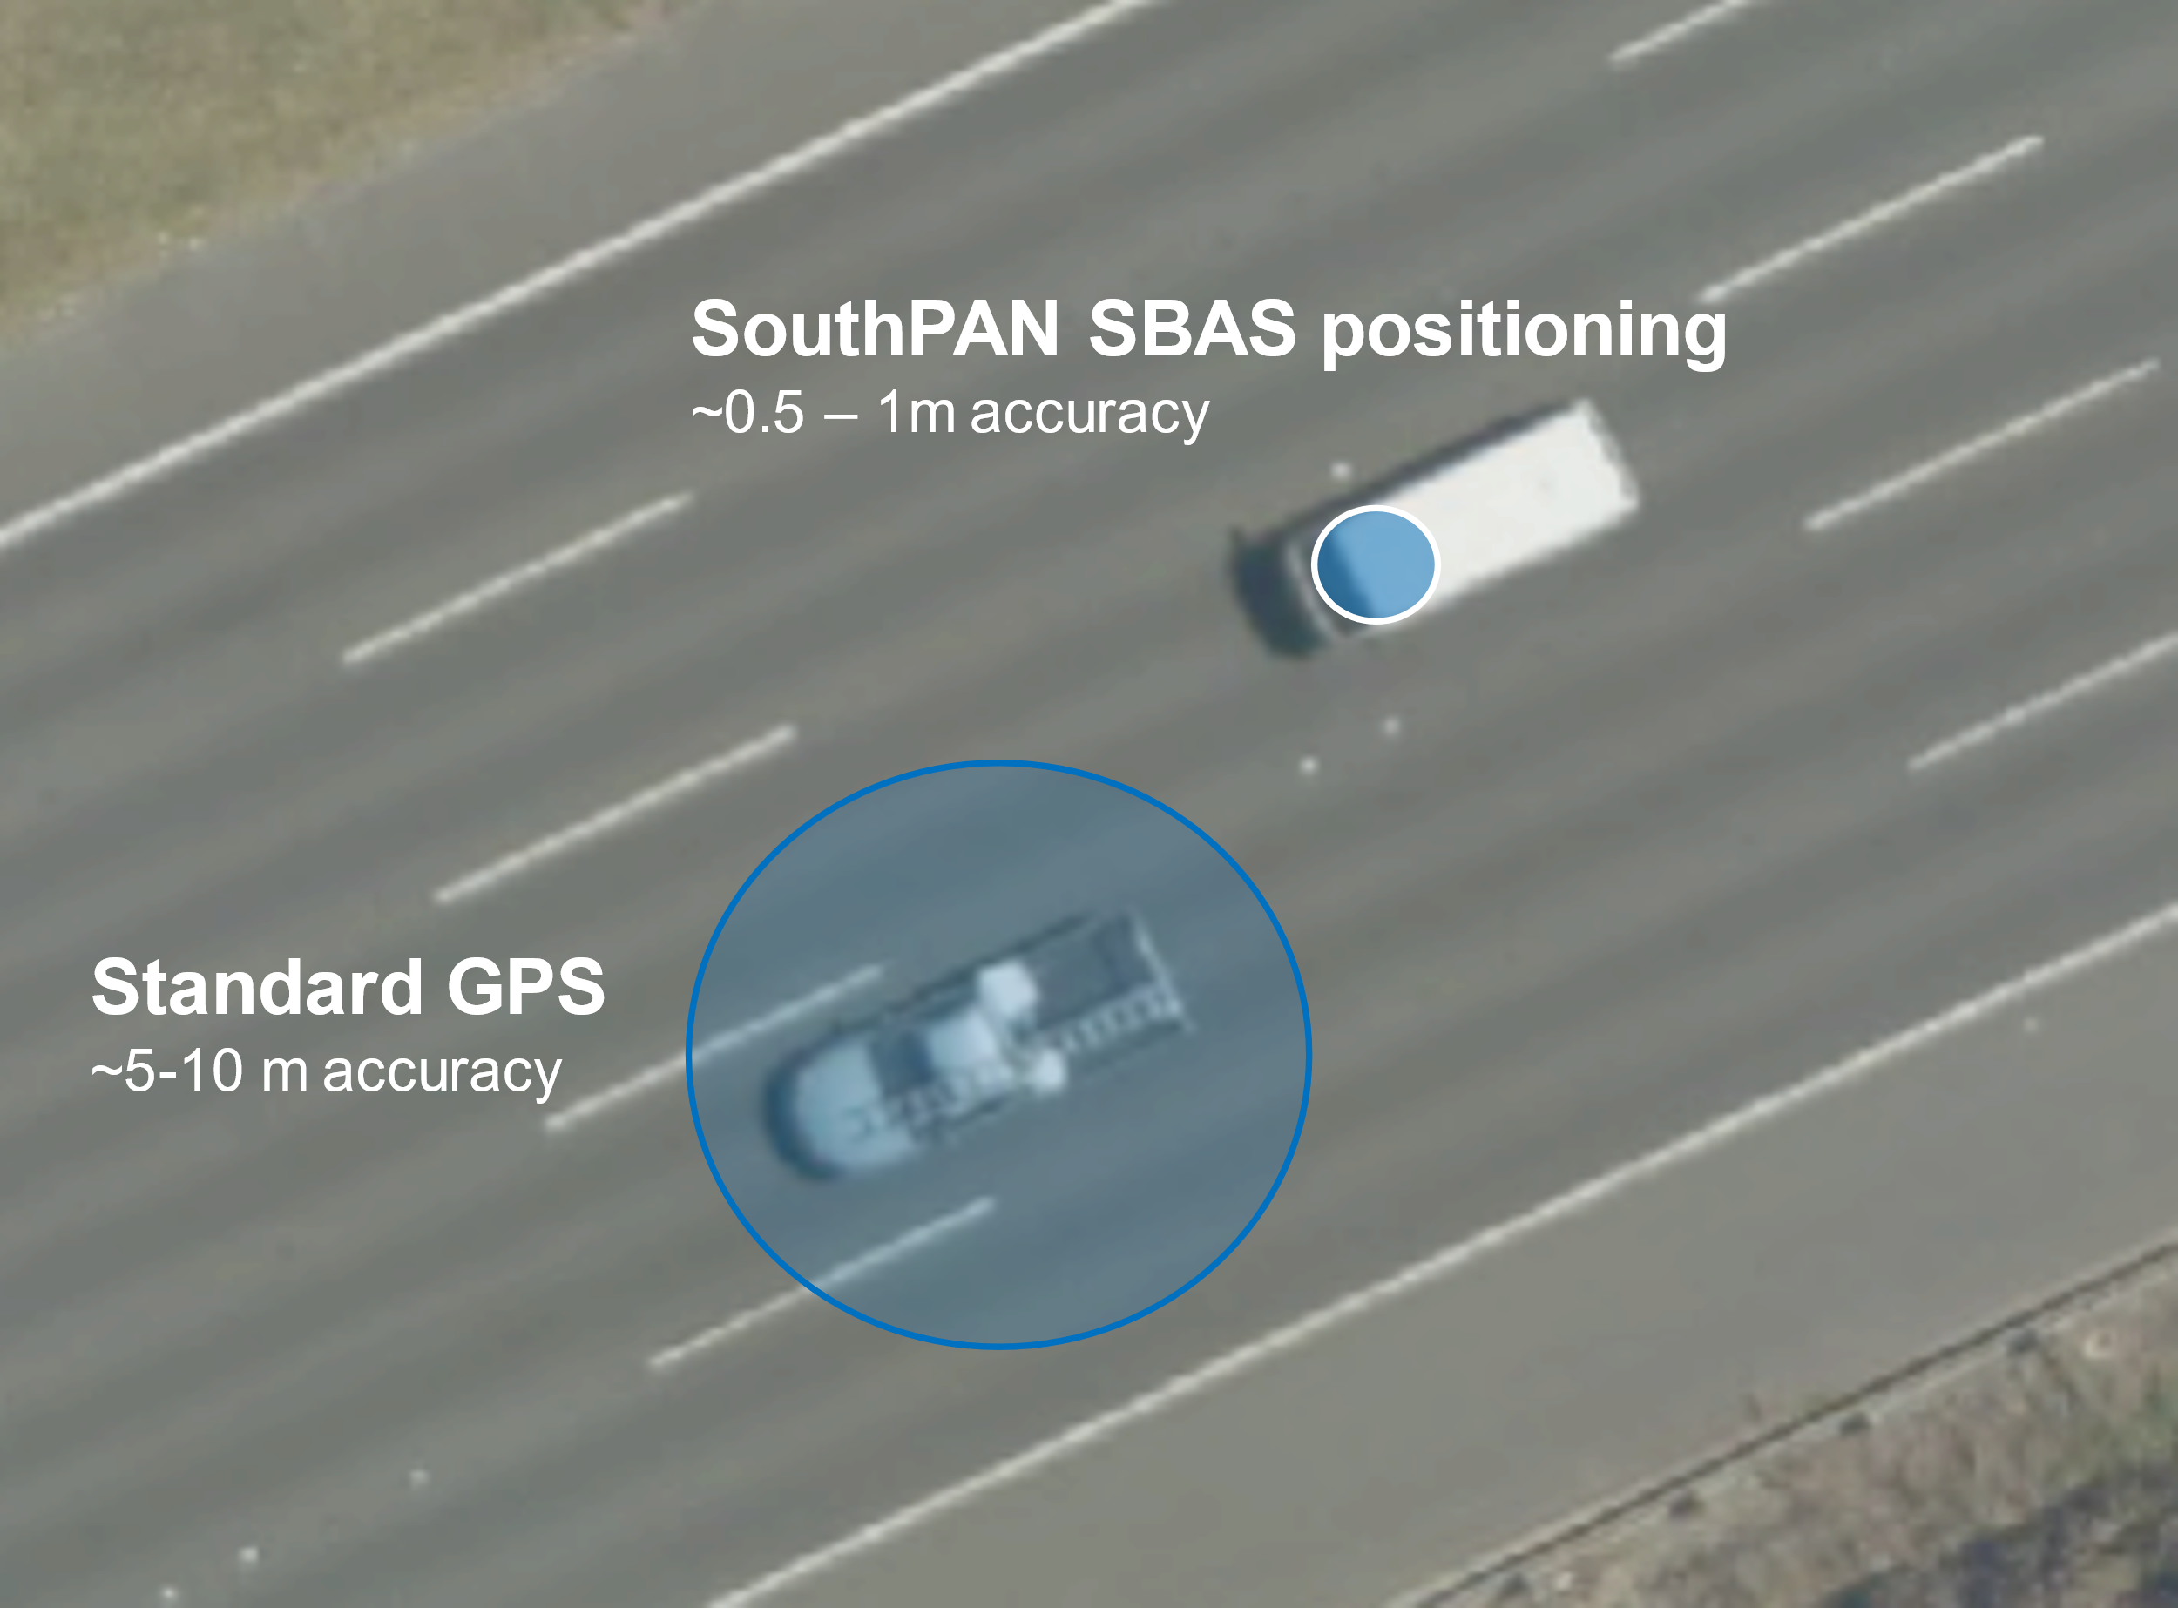
How accurate is GPS with SouthPAN?
Standalone GPS devices such as in a vehicle or smartphone have a positioning accuracy of several metres. This is due to a range of sources of error that degrade how accurately GPS is measuring position. When GPS devices apply the SouthPAN SBAS correction signals, the accuracy can improve to one metre or even less.
In a transport example, the level of improvement enhances the positioning of a vehicle on the right road to positioning a vehicle within the right lane. It can also enable lane-level guidance for a driver.
SouthPAN offers an additional Precise Point Positioning service that can achieve GPS positioning accuracy to 10 cm, although this requires specialised equipment and software and can take up to 60 minutes to achieve.

How does SouthPAN work?
The SouthPAN GPS correction signals are computed from a dedicated network of GPS ground stations. SouthPAN compares satellite data with the precisely known positions of the ground stations, and then sends computed GPS corrections to two geostationary satellites. These corrections are broadcast across Australia, New Zealand and maritime regions. GPS devices receive the GPS corrections just like standard GPS signals and apply them to improve the positioning accuracy.

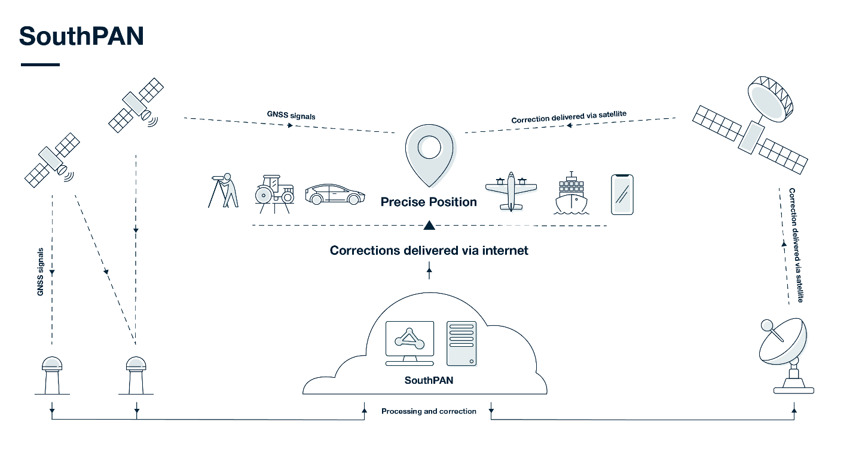

What are the SouthPAN correction signals?
SouthPAN will be implemented over the next five years with new infrastructure and progressive improvements in available services.
Service | Accuracy capability | Summary details
SBAS Corrections  Single Frequency (L1 SBAS)  Dual Frequency Multi-Constellation (DFMC SBAS) | 0.5-2 m  0.5-1 m | These two services can provide instant sub-meter level accuracy with improved integrity.  To ensure high integrity, L1 SBAS will be certified for Safety-of-Life Service by 2028 to enable use in aviation and safety-critical applications.
Precise Point Positioning via SouthPAN (PVS) | 10 cm | The PVS service enables as good as 10-centimetre level positioning although it can take up to 60 minutes to achieve this level of accuracy.

How can you access SouthPAN?
SouthPAN Early Open Services are available now and broadcasting GPS correction signals across the region.
SouthPAN has been designed to work with existing GPS technology which means users don’t need any special equipment to benefit from sub-meter accuracies of the L1 SBAS corrections at no added cost.
However, because SouthPAN is new to our region, not all GPS devices support SouthPAN and, for those that do, firmware updates are required. It will take time for the benefits to be fully realised and to become available in consumer equipment.
Engagement is underway with GPS manufacturers to ensure SouthPAN correction signals are automatically received and applied in mass-market GPS-enabled devices. Hardware and firmware upgrades may be required to activate the SouthPAN SBAS corrections.

Will SouthPAN improve the blue dot on my smartphone?
Many smartphones can already receive SouthPAN SBAS signals. However, they do not currently apply the corrections to the GPS position.
In the coming years, enhanced chipset receivers capable of applying SouthPAN SBAS corrections will be integrated into smartphones. If applied within the device, this will mean that the blue dot in mapping applications may be smaller and more accurately positioned.

Advantages of SouthPAN SBAS GPS corrections?
Advantages | SouthPAN
Cost and accessibility | SouthPAN SBAS corrections are free and directly compatible with existing mass-market GPS-enabled devices.  In contrast, higher accuracy commercial GPS correction services require paid subscriptions, specialised equipment and technical configuration.
Availability | SouthPAN GPS correction signals are delivered by satellite (or the internet) and are available across the entire Australia, New Zealand and maritime zones.
Integrity | SouthPAN is designed to be very reliable with high level service availability.  By 2028 the L1 SBAS service will be certified for Safety-of-Life Service to enable use in aviation and safety-critical applications.

Who will benefit from SouthPAN?
SBAS corrections are primarily used in aviation as the technology provides increased navigational accuracy, integrity and availability crucial for safety-critical operations including continuous vertical guidance during landing procedures. SouthPAN will enable SBAS corrections to be applied in aviation across Australia and New Zealand and it is compatible with other regional SBAS. This will provide a significant boost to air transport and safety in remote and regional Australia.
In addition to aviation, SouthPAN will increase GPS positioning accuracy and integrity across a range of applications in all sectors of business and the community. Maritime, road, rail, agriculture, construction, resource and utility sectors will benefit, bringing Australia and New Zealand in line with services currently available in the Northern Hemisphere.
The economic, social and environmental benefits of improved positioning technology were assessed for SouthPAN across a wide range of applications, as shown in the table below.
Sector | Example applications
Aviation | Precision landing and navigation
Maritime | Improved safety of navigation in congested waters and avoiding hazards, under-keel clearance, protection/exclusion zoning, enhanced port operations
Transport | Advanced navigation, enhanced fleet management, reduce accidents, supporting vehicle automation
Rail | Safer rail operations, improved track-determination and traffic management, improved network defect locating
Agriculture | Precision machinery monitoring, spraying, yield mapping, inter-row seeding, livestock management
Construction | Improved personnel safety through smart geofencing
Utilities | Locate underground services

Does SouthPAN use the existing GPS ground station infrastructure?
No, SouthPAN will operate on a new regional network of GPS ground stations independent of the national, state and commercially managed GPS ground station networks. SouthPAN will establish 35 GPS ground stations across the region that are designed to meet strict quality and reliability requirements to support the safety-of-life certification of the system.
As part of the broader national positioning program, the existing state and national GPS ground station networks have been integrated to form the National Positioning Infrastructure Capability. Data from these GPS ground stations is openly available and currently used by commercial operators to deliver higher accuracy GPS correction services.

How does SouthPAN fit in with other forms of GPS corrections already available?
There are a range of existing higher accuracy GPS correction services that rely on the data streams from state and national GPS ground station networks. These services can support cm-level positioning and have been used for many years across a range of applications including precision agriculture, construction surveying and mapping.
These commercial services require paid subscriptions, specialised equipment, technical configuration and, in many cases, mobile data coverage. However, open access to state and national GPS ground station data and progress towards supporting mass-market applications are both reducing costs and increasing access to higher accuracy GPS correction services.
Although SouthPAN does not provide as high accuracy as commercial services, it is a complementary GPS correction service that is free and prioritises widespread availability and integrity.

More information
More information on SouthPAN is available from Geoscience Australia and Toitu Te Whenua Land Information New Zealand.
Southern Positioning Augmentation Network (SouthPAN) | Geoscience Australia
SouthPAN | Toitū Te Whenua - Land Information New Zealand (linz.govt.nz)
Within the Victorian State Government, Land Use Victoria positioning experts are closely monitoring the implementation of SouthPAN infrastructure and services, as well as adoption in GPS-enabled devices. Advisory and technical support is available from SMES Support:
Email: smes.support@delwp.vic.gov.au

