|  |
| --- |
| Vicmap Product Development |
| Change Advisory Notice # 269 |

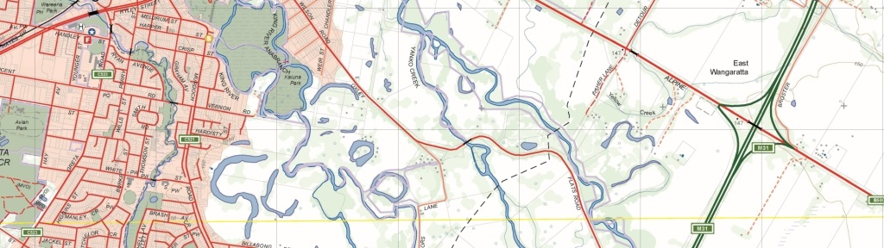

Vicmap IUF seed – Transition to GDA2020

## What is happening

In February 2021 DELWP communicated, though the Vicmap Bulletin, indicative plans to transition the Vicmap Incremental Update Format (IUF) seed and weekly files into GDA2020. This Change Advisory notice provides scheduling information for the transition including the withdrawal of GDA94 from supply.

Regarding the file naming convention, the header in the XML for current GDA94 supplies is LLD GDA94 and will remain unchanged. The header in the XML for GDA2020 supplies will be LLD GDA2020. An example is given below:

**GDA94 Files**

lganame_iuf_data_dd-mmm-yyyy.xml

Examples

* ballarat_iuf_data_14-mar-2021.xml
* golden_plains_iuf_data_14-mar-2021.xml

**GDA2020 Files**

lganame_iuf_data_gda2020_dd-mmm-yyyy.xml

Examples

* ballarat_iuf_data_gda2020_14-mar-2021.xml
* golden_plains_iuf_data_gda2020_14-mar-2021.xml

## Why this change is occurring

To support the adoption and transition to GDA2020, the official datum and map projection for Australia: GDA2020 is a conventional static datum based on ITRF2014 at the reference epoch of 1 January 2020. The product transition from GDA94 to GDA2020 is consistent will previous datum transitions in Vicmap (i.e. AGD66 to GDA94).

Realign with our annual data supply schedule of the IUF seed in the month of February each year.

## Who it will affect

This change will affect all users of Vicmap IUF seed and weekly files.

## When the change will occur

* 1. Please note the following planned dates:

|  |  |  |
| --- | --- | --- |
| **Product** | **Action** | **Date & Frequency** |
| Vicmap Land Administration Themes | The 2021 Vicmap Incremental Update File (IUF) Seed will be available in GDA94 and GDA2020.  GDA2020 newly added.  This will be the last Vicmap IUF Seed supply in GDA94. | 14 May 2021  Once off |
| Vicmap Land Administration Themes | The weekly Vicmap Incremental Update File (IUF) file will be available in GDA94 and GDA2020.   * 1. GDA2020 is newly added. | 14 May 2021  Weekly on Fridays until February 2022 |
| Vicmap Land Administration Themes | The 2022 Vicmap Incremental Update File (IUF) Seed will be available in GDA2020 only.  GDA94 will be withdrawn. | February 2022 |
| Vicmap Land Administration Themes | The weekly Vicmap Incremental Update File (IUF) file will be available in GDA2020 only. | February 2022  Weekly on Friday’s and ongoing |

## How to provide feedback

Feedback welcome until **11 June 2021.**

For Vicmap Product change notices and bulletins, go to the [News and Bulletins](http://www.delwp.vic.gov.au/parks-forests-and-crown-land/spatial-data-and-resources/news-and-bulletins) page.

For further information & feedback please email [vicmap.help@delwp.vic.gov.au](mailto:vicmap.help@delwp.vic.gov.au)

|  |  |
| --- | --- |
| © The State of Victoria Department of Environment, Land, Water and Planning 2021  LogoThis work is licensed under a Creative Commons Attribution 4.0 International licence. You are free to re-use the work under that licence, on the condition that you credit the State of Victoria as author. The licence does not apply to any images, photographs or branding, including the Victorian Coat of Arms, the Victorian Government logo and the Department of Environment, Land, Water and Planning (DELWP) logo. To view a copy of this licence, visit http://creativecommons.org/licenses/by/4.0/  Disclaimer  This publication may be of assistance to you but the State of Victoria and its employees do not guarantee that the publication is without flaw of any kind or is wholly appropriate for your particular purposes and therefore disclaims all liability for any error, loss or other consequence which may arise from you relying on any information in this publication.  **Vicmap Disclaimer**  The State of Victoria:  a. does not give any representation or warranty as to the accuracy or completeness of DELWP spatial data, Vicmap data (including metadata) or Vicmap product specifications or the fitness of such data or products for any particular purpose;  b. disclaims all responsibility and liability whatsoever for any errors, faults, defects or omissions in such data or products.  Any person using or relying upon such data or products must make an independent assessment of them and their fitness for particular purposes and requirements. | Accessibility  If you would like to receive this publication in an alternative format, please telephone the DELWP Customer Service Centre on 136186, email [customer.service@delwp.vic.gov.au](mailto:customer.service@delwp.vic.gov.au), or via the National Relay Service on 133 677 [www.relayservice.com.au](http://www.relayservice.com.au). This document is also available on the internet at [www.delwp.vic.gov.au](http://www.delwp.vic.gov.au). |

Keep all content above this instruction text line. Delete only when document formatting is complete.